Purpose: This document includes instructions for adding the Colorado State University (CSU) Systems Engineering (SE) Department Diversity, Equity, and Inclusion (DEI) calendar. Based on your preferred version of Outlook, there are two ways to add the calendar:
- Outlook-Desktop Version
- Outlook-Web Version

Adding the CSU SE DEI Calendar on Outlook-Desktop Version
Last updated: 2021/10/22 by Dan Herber
- Open Outlook. In the Home tab, navigate to the Add button. In the dropdown menu, select From Address Book…
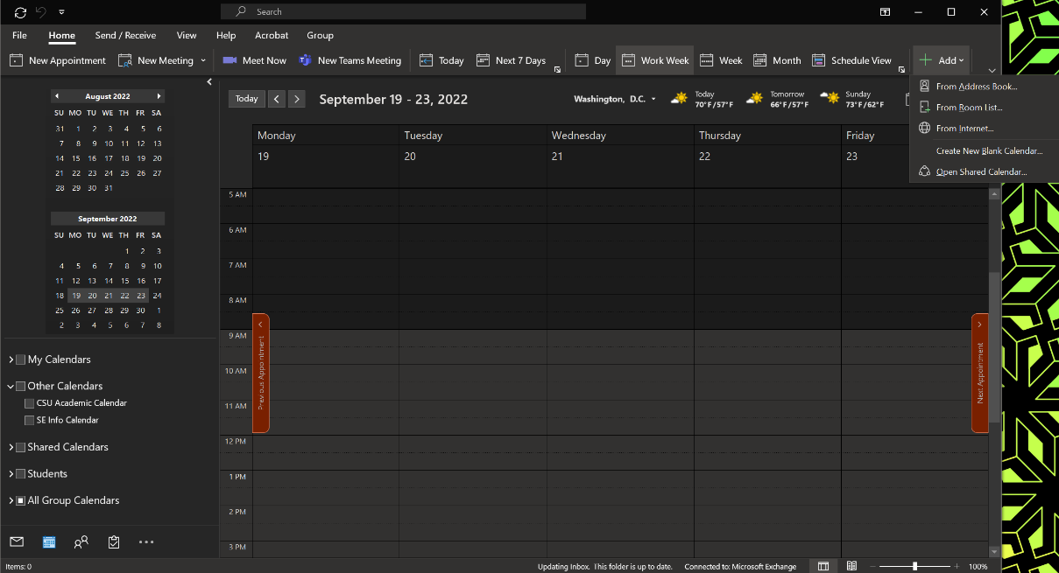

- In the search area (top left corner), type Engr-Sys DEI. Select with a double click Engr-Sys DEI from the list below (should be the first entry). It should appear now in the bottom row of this window next to Calendar. Now, select OK.
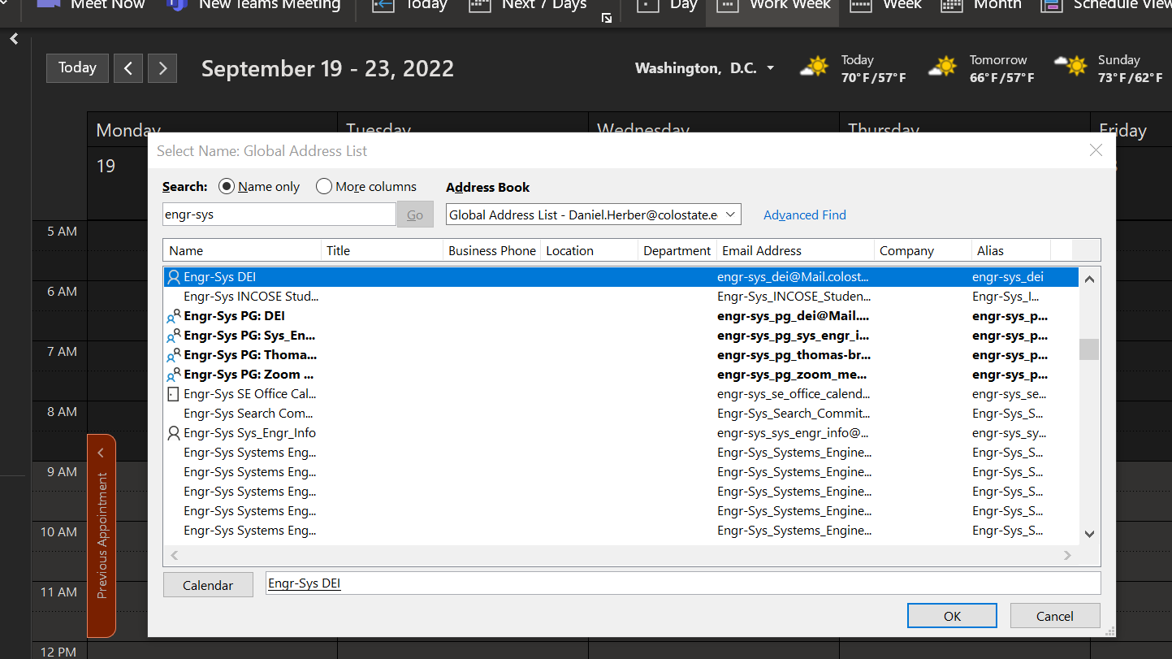
- The calendar has now been added to your calendars. It may not be in the group that perfect so you can move it be dragging it to the desired group (here the group is “Other Calendars”). You can change the calendar color if you desire (it is shown as red in this case). You can also toggle the calendar on and off using the checkbox to the left of the calendar name.
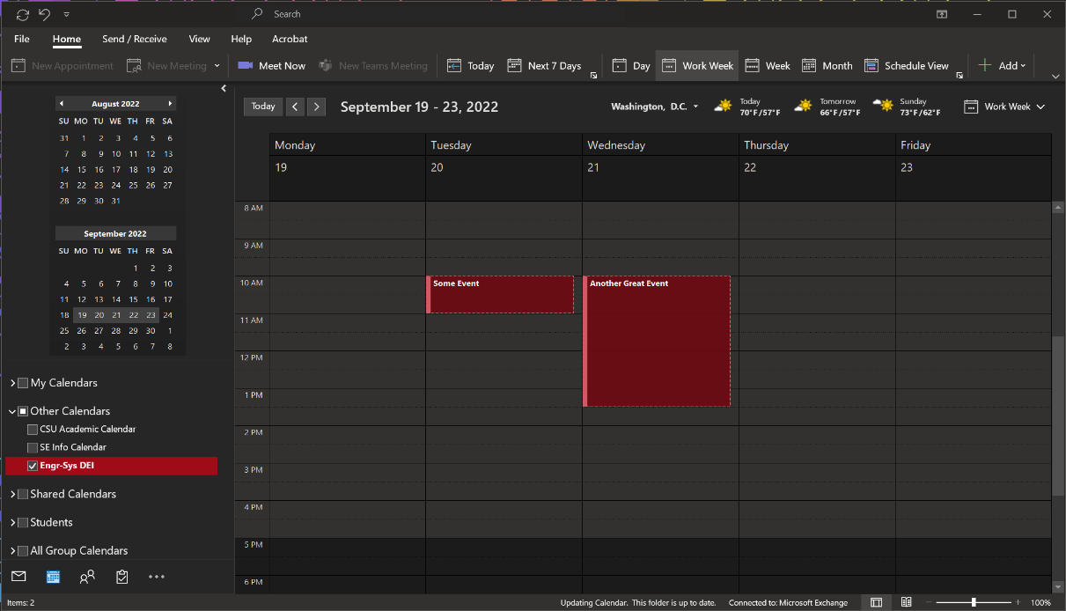

Adding the CSU SE DEI Calendar on Outlook-Web Version
Last updated: 2021/10/22 by Dan Herber
- Navigate to your Outlook web calendar. Find the “Add calendar” button and click on it.
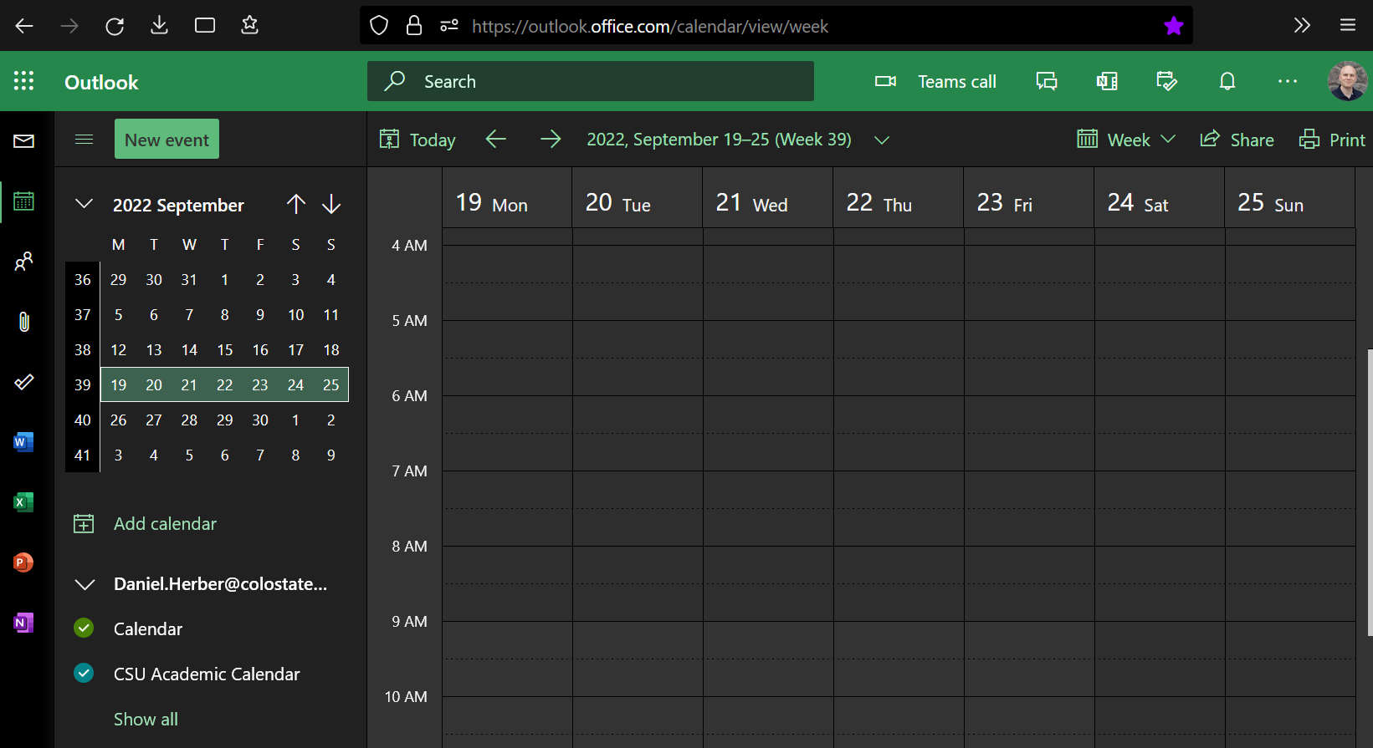
- A window should pop up. In the right-side menu, navigate to “Add from directory”. In the area with the blank horizontal link, type engr-sys_dei@Mail.colostate.edu. Select the option that appears.
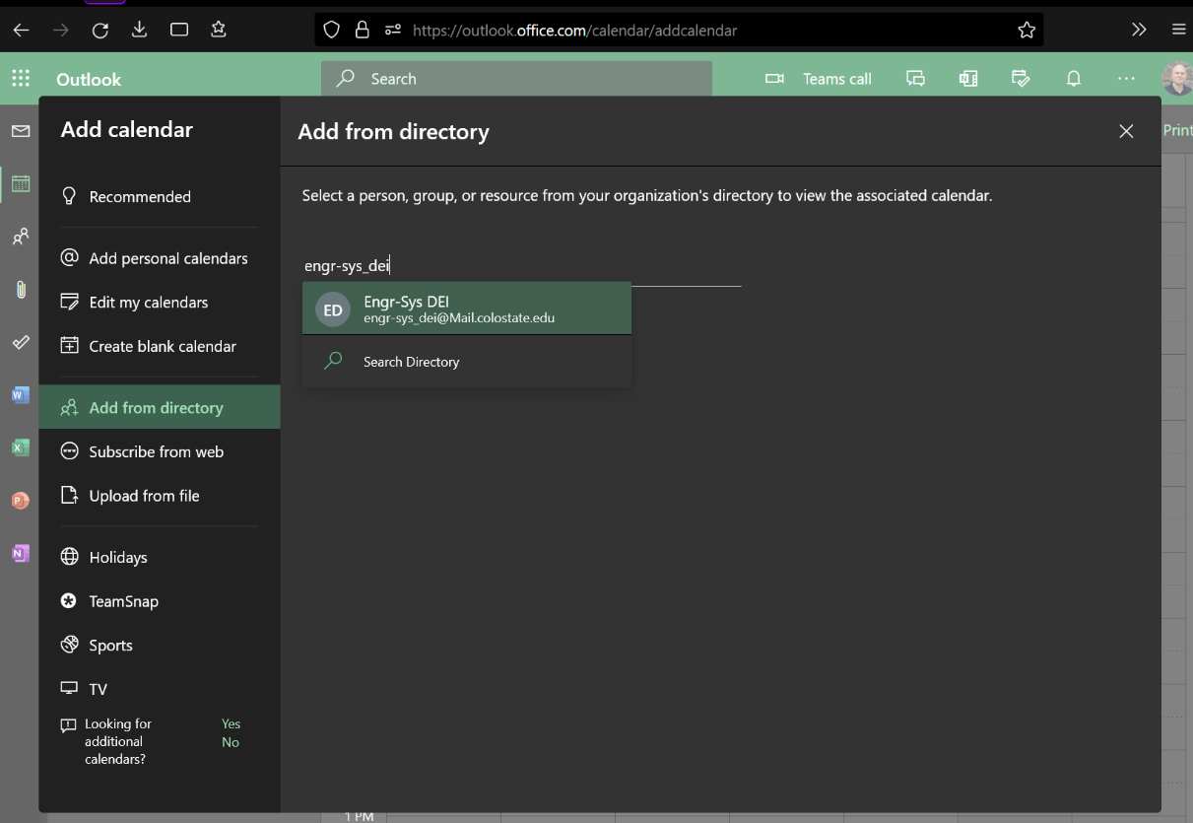
- Once you have selected the Engr-Sys DEI email, you will be allowed to add this calendar to a group. You can select any group you would like. The one shown below is named “Other calendars”.
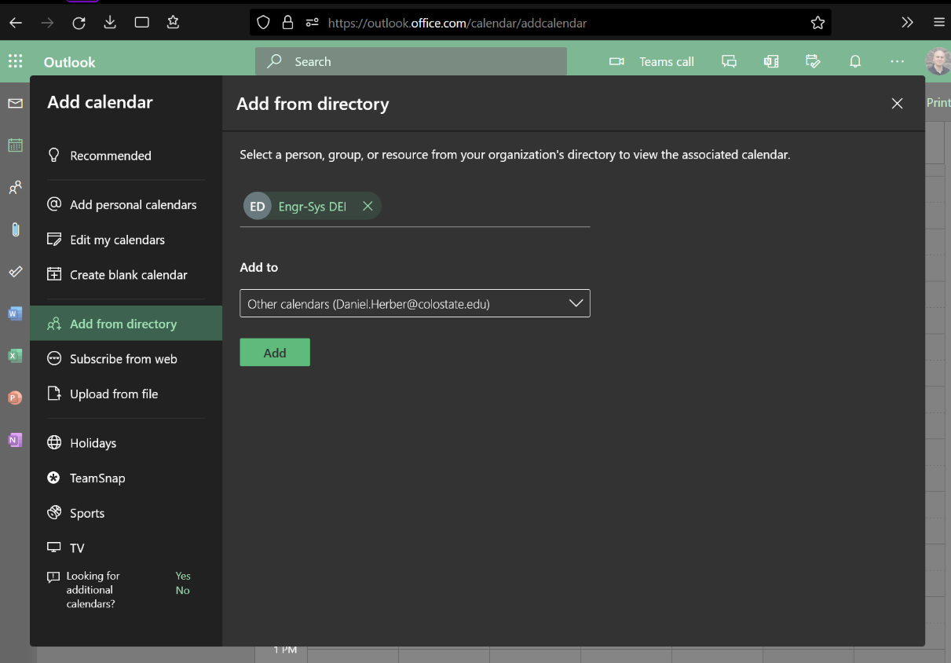
- You will now have the Engr-Sys DEI calendar in the group you specified. You can change the calendar color if you desire (it is shown as red in this case). You can also toggle the calendar on and off using the circular button to the left of the calendar name.
