2010 WEF Wastewater Challenge Competition

CSU Environmental Engineering Society
Design Report

June 2010
CSU Environmental Engineering Society
American Waterworks Association
&
Water Environment Federation
Student Chapter

Kelly Bergdolt, Jeff Lasker, Victor Sam, Alicia Shogbon, Darren Wood
Table of Contents

1. Problem & Initial Assessment……………………………………………….. 1
1.1 Introduction………………………………………………………… 1
1.2 Contributing Contaminants ………………………………………... 2
2. Design Approach……………………………………………………………. 4
2.1 Design Operations………………………………………………….. 6
3. Environmental Impacts……………………………………………………... 7
4. Cost Analysis……………………………………………………………...… 8
5. References…………………………………………………………………… 9
A.1 Appendix…………………………………………………………………... 9

~List of Figures
Figure 1. Influent Constituents………………………………………………… 1
Figure 2. Argo Water Treatment Plant Schematic…………………………….. 5
Figure 3. Treatment System Schematic……………………………………….. 6
Figure A.1 Design…………………………………………………………….. 9
Figure A.2 Dresser Price Quote………………………………………………. 10
Figure A.3 Felt Price & 5 Quart Bucket Price………………………………... 10

~List of Tables
Table 1. Wastewater Components & Contribution to Water Quality………… 2
Table 2. Pilot Water Quality Test Results…………………………………….. 4
Table 3. Material & Operational Costs……………………………………….. 8

1. Problem & Initial Assessment________________________________________
1.1 Introduction
As of result of torrential storms, the local wastewater treatment plant’s capacity had been exceeded, causing a number of manholes to overflow on to a neighborhood street. Downstream of the neighborhood is the town’s drinking water supply. The task to be done is to design and build an emergency treatment system to treat the sanitary sewer overflow before it could contaminate the drinking water supply. Due to this unfortunate event occurring on the evening of Thanksgiving Day, no stores were open to provide supplies; the supplies utilized in the treatment system must be resources found in local garages.
The wastewater components and specific loadings of each constituent were given in the
2010 WEF Wastewater Challenge Guidelines which are presented in Figure 1 below. The components will be mixed in with 10 gallons of local tap water the night before the wastewater competition to be treated by the designed and fabricated systems.

Figure 1. Influent Constituents
1.2 Contributing Contaminants
An empirical evaluation of the wastewater was done to differentiate how each contaminant affected the overall water quality of the wastewater. The results of this evaluation can be seen in Table 1. Notice this wastewater can be predicted to having a high dissolved organic content and significant turbidity.

Table 1. Waterwater components & contribution to water quality
 | Conductivity | pH | Turbidity | DOC | DO
Iodized Table Salt | 
Coffee Grounds |  |  |  | 
Potting Soil |  |  |  | 
Grass |  |  |  | 
Orange Juice |  |  |  | 
Vegetable Oil |  |  |  |  | 
Plant Leaves |  |  |  | 
Toilet Paper |  |  |  |  | 
Hand Soap |  |  |  |  | 
Corn Starch |  |  |  |  | 
Toothpaste |  |  | 
Cottage Cheese |  |  |  |  | 

When considering the wastewater quality in terms of electrical conductivity, pH, turbidity, dissolved organic carbon (DOC) and dissolved oxygen (DO), the following contaminant evaluations are the believed to be the most significant contaminants listed from the guidelines because of their effects on water quality and higher reactive concentrations.
Salt- Table salt is comprised of NaCl which dissolves in water readily to its ionic counterpart Na⁺ and Cl⁻. The consequence of increasing the concentration of ions in water results in an increase in the conductivity. Conductivity is the measurement of free ions in the water and is closely related to salt concentrations in natural water streams.
Orange Juice- The major contributing aspect of orange juice in our waste water will be a change in pH. Since orange juice contains citric acid (C₆H₈O₇), it will act as the single greatest contributor to pH in the waste water. The pH of orange juice alone ranges from 3 to 4.
Vegetable oil- Vegetable oil is comprised mostly of fats and lipid materials, the overall DOC will increase due to the presence of insoluble organic matter. The vegetable oil will also decrease the DO levels in the water due to the biodegradability of the oil and then utilization of oxygen. Oil is a source of BOD (Biochemical Oxygen Demand).
Since oil is less dense than water it floats on top, one detrimental effect of this phenomenon is the oil prevents any oxygen to diffuse through to the water because it forms a barrier between the atmosphere and water.
Corn Starch- As a fine white dissolvable powder, corn starch will contribute greatly to the turbidity of the water. Since turbidity is the measure of the cloudiness of the water all of the corn starch will add to the turbidity. Some of the corn starch will be dissolved and be another source of BOD to the wastewater and any water supply it enters.
Cottage Cheese- Conceivably the cottage cheese will be the single greatest contribution to DOC. This is because the cottage cheese contains a high concentration of proteins and is a result of bacterial activity. Since cottage cheese has already gone through a curding process, the protein complexes are weakened and are readily dissolved in water.
After analyzing the contribution of the components of the wastewater, a sample of the water was prepared. This wastewater was then tested according to the water quality parameters judged in the competition. As shown in Table 2. the pH is too low, turbidity is too high, dissolved oxygen is too low and the conductivity is too high. If this water were to contaminate the drinking water supply it could impair the water source causing taste and odor issues and potentially result in increased levels of dissolved manganese and iron.
Table 2. Pilot Water Quality Test Results

2. Design Approach____________________________________________________
After the wastewater was analyzed, proper water treatment methods were chosen for their roles in improving certain water quality parameters targeting specific contaminants determined. The effects of alkalinity were considered for the design of the treatment system. Alkalinity is essentially an expression of the buffering capacity of water, in other words the resistance of the water to any pH changes. Alkalinity is calculated by the equation,

Alk = [HCO₃⁻] + 2 [CO₃⁻²] + [OH⁻] – [H⁺]

The City of Phoenix’s 2008 Water Quality Report indicates that the tap water in Phoenix has alkalinity levels ranging from 103 ppm (ppm = mg/L)* to 183 ppm* deeming the local water in Phoenix to have a greater ability in neutralizing acids than the wastewater created at the CSU Lab in Fort Collins, Colorado which has lower alkalinity levels averaging only 40 mg/L* as stated by the 2006 Fort Collins Utilities' Water Quality Report. From a wastewater standpoint, alkalinity around 200 mg/L would be considered high according to typical composition of domestic wastewaters. It is believed that the potting soil and toothpaste may also contribute to the alkalinity of the wastewater. For this reason, the design adjusted to treat a more buffered water as of result of a potential increase in concentration of alkalinity.

It is believed that pH will be the most significant driving factor affecting the quality of the wastewater. pH needs to be optimized to 7, it affects the solubility of the contaminants. A neutral pH will induce some dissolved solids to precipitate out and be easily removed by filtration, thus removing the dissolved solids that may be contributing to conductivity. By filtration of these suspended solids the turbidity is also reduced.
The designed treatment system was based on a conventional treatment process. The Argo Tunnel Water Treatment Plant in Idaho Springs, Colorado, as seen in Figure 2, utilizes a simple yet very effective process, removing 99.9% of the heavy metals from the Clear Creek River. Similar to the Argo Treatment plant the design proposed for this project utilizes an equalization basin, a clarifier and a mixed media filter.
Figure 2. Argo Tunnel Water Treatment Plant Schematic

The main structure of the system is supported by an ordinary clothing dresser. The dresser was selected for its structural integrity and easily accessible compartments. The dresser will be the support for our storage basin on top and the drawers provide a container for the filter media. A schematic of the system can be seen in Figure 3. A description of each of the sections of the system is explained in the Design operations on the next page.

Figure 3. Treatment System Schematic

2.1 Design operations
Screen Filter- First screening device in the process is provided by window screen meshing. This stage removes large particles such as the leaves and grass present in the waste water in this case simulating bar screening.
Slot Aeration- The water is then poured through a suspended bucket with slots cut ¼ inch from the bottom. The commercially available liquid clog remover (Drano®) will be added here for pH adjustment. By forcing water through slots the water is physically separated exposing more surface area for air to contact thus performing some preliminary aeration. The more aeration achieved by the system the better quality the treated water will be.
Settling/Baffling- The combination of baffling and settling will allow for larger particles in the waste stream to settle to the bottom of the tank. The baffle is constructed by hollowing a 5 quart bucket utilizing its high walls to dissipate energy and trap suspended solids. The walls will be directly underneath the catchment bucket to collect the majority of the inflow. A large amount of the settleable contaminants will be contained within the first level of the treatment design as particles are allowed to settle down and the water is withdrawn from a few inches about the tote.
Sand filtration- A plate will be placed on top of the sand filter to distribute the inflow evenly and to dissipate energy that may damage the filter. Sand filters allow for a small pore size to be achieved without having to use energy and without needing man made filters for the water to travel through utilizing physical exclusion. The sand is contained in the 5 gallon buckets with high depth to obtain a longer path for the water to flow through.
Carbon Filter- In this step dissolved organic compounds and synthentic organic chemicals that pass through the sand and A/C filters are aimed to be removed. Carbon utilizes the physical process of adsorption in order to remove the finer particles in the water and utilizes van der Waals and London dispersion forces. The charcoal is broken down to smaller pieces to allow the carbon to have a high surface area for maximum contact time between filtrate and carbon. As the dissolved organic particles pass over the carbon, they become attached and are removed from the water. For this level of treatment and for the scope of the project charcoal/carbon is the most feasible way to remove any color or dissolved organic compounds from the waste water.
Fine A/C filter- Serving much like the sand filter, the A/C filter will act as a polishing step in the filtration process. It is important for any water filtration deceive to have an extra step of treatment so that if one process fails to operate effectively the second one would be there to ensure standards are met.
Aeration- The second step of aeration will further contribute to the DO for the waste water effluent.
3. Environmental Impacts______________________________________________
The materials used for the design are economically feasible and recyclable. The design uses minimal chemicals so any disposal and replacement is easy and safe. The sand and charcoal filters are layered for easy removal and can be composted or regenerated after used. All the materials don’t require routine maintenance with the exception of the air filter, which is relatively cheap and can be composted as well. Most of the dresser was used in the design, the drawers that were taken out were then modified to provide structural stability and all the screws taken out of the tracks were used to support the shelving that was built to support the buckets.
During times of non-crisis, the design can be used as a gray water treatment system for a household because it is designed to treat wastewater with a higher loading rate. Gray water can be defined as water containing minimal concentrations of pathogens and organics, usually from bathroom sinks as well as laundry and shower effluents. The treated grey water can then be used for irrigation reducing household water demand.
4. Cost Analysis_______________________________________________________
Overall project cost can be observed in Table 3. The cost and list of materials were again obtained by the 2010 WEF Wastewater Challenge Guidelines. The main appraoch was to use as few materials as possible while still maintaining structural stability and efficiency of the design. The three items not on the material list are highlighed in light blue their reciepts/price quotes may be found in the appendix. The dresser is noted to be recycled from the trash so a similar dresser was used for the price quote.
Table 3. Materials & Operational Costs.
Item | Per Unit price ($) |  |  | # units | cost ($) |  | $129.00 | Materials Cost
3/4" Thick. Plywood | $1.06 | per | Sq. Ft | 4 | $4.24
1.5" PVC Pipe | $0.30 | per | lin ft | 2.5 | $0.75 |  | $22.00 | Operational Cost
18 Gallon tote | $5.00 | per | tote | 2 | $10.00
36 Gallon garbage bag | $0.63 | per | bag | 5 | $3.15 |  | Total cost: | $146.76
Charcoal | $0.50 | per | lb | 10 | $5.00
Coffee filter | $0.03 | per | filter | 20 | $0.60
Duct tape 20 yd roll | $10.00 | per | roll | 1 | $10.00
5 gallon bucket | $2.50 | per | bucket | 2 | $5.00
Play sand | $0.10 | per | lb | 4 | $0.40
Steel Wool* | $0.83 | per | pad | 10 | $8.30
screws | $0.05 | per | screw | 12 | $0.60
stainless steel safety wire | $0.25 | per | lin ft | 3 | $0.75
Felt | $1.50 | per | Sq. Ft | 2 | $3.00
5 qt bucket | $1.98 | per | bucket | 3 | $5.94
dresser | $59.00 | per | dresser | 1 | $59.00
Window Screen Mesh | $0.31 | per | Sq. Ft | 3 | $0.93
Silocone | $6.00 | per | tube 10 oz | 1 | $6.00
standard air conditioner filter | $2.67 | per | filter | 2 | $5.34
caulking gun | $2.00 | per | unit-hour | 0.25 | $0.50
operator costs | $25.00 | per | unit-hour | 0.75 | $18.75
standard builder's hammer | $5.00 | per | unit-hour | 0.25 | $1.25
utility knife | $2.00 | per | unit-hour | 0.5 | $1.00
wire cutters | $2.00 | per | unit-hour | 0.25 | $0.50

5. References_______________________________________________________
City of Fort Collins (2006) Fort Collins Utilities 2006 Drinking Water Quality Report. Fort Collins, CO

City of Phoenix Water Services Department (2008) 2008 Water Quality Report. Phoenix, AZ

U.S. Environmental Protection Agency (USEPA) (2007) Central City/Clear Creek Superfund Site. http://www.epa.gov/region8/superfund/co/ccclearcreek/Update/2007clearck.pdf

Water Environment Federation (2010) “WEF Wastewater Challenge”

A.1 Appendix_____________________________________________________
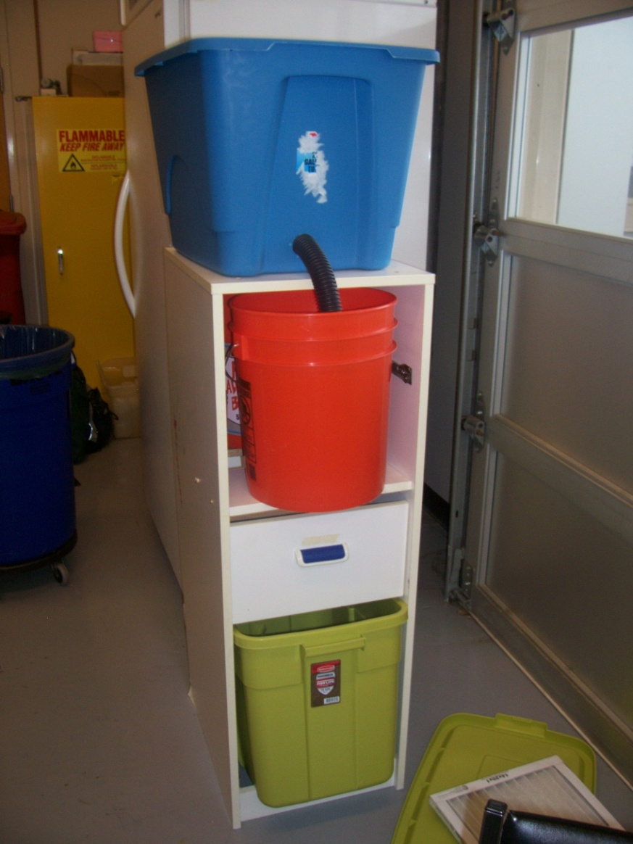
Figure A.1 Design
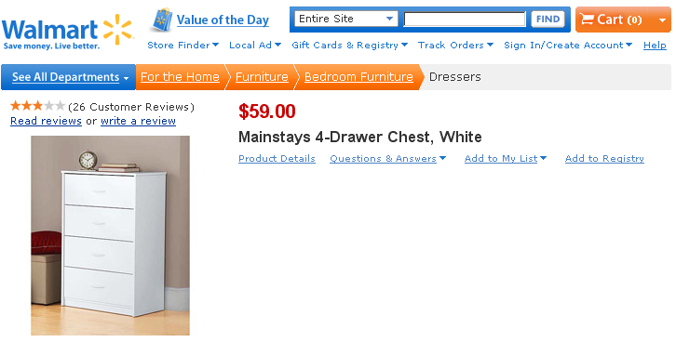
Figure A.2 Dresser Price Quote from Walmart
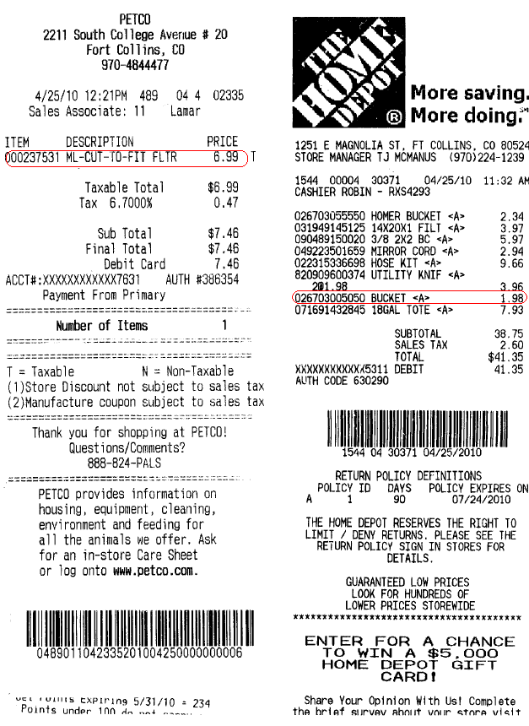
Figure A.3 Felt Price & 5 Quart Bucket Price

