The Product Realization Process

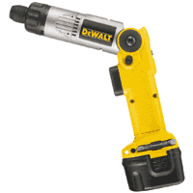



The success of a manufacturing firm rests on its ability to successfully develop quality products. Successful development of products requires the ability to:
1. Identify customer needs
2. Quickly create products that meet those needs (i.e. quality products)
3. Produce these products a low cost.
One way to ensure that these objectives are met,is to employ a structured product realization process for each product development effort. This series of lectures (week 3, 6 and week 8) will provide an introduction to the product realization process, with a focus on concept development efforts.
Objectives of this Course Module (Week 3, 6 and 8)
At the completion of this series of lectures, each student should be able to achieve the following technical objectives:
- Estimate the scope and scale of a product development effort by examining a variety of examples
- Approach product development using a structured six-phase process.
- Develop an opportunity statement for a new product.
- Evaluate an opportunity using a basic 5-step process.
- Define the value proposition of your venture and develop a draft business model.
- Develop a product development mission statement for development of a new product.
- Gather raw customer needs data from a group of potential customers
8. Translate the raw customer needs data into an identified customer needs.
9. Translate subjective customer needs into precise target specifications.
The Product Realization Process
A product realization process is the sequence of steps or activities which an enterprise employs to conceive, design and commercialize a product.

The product realization process consists of 6 phases. During each of the 6 phases, marketing, design and manufacturing functions play key roles, along with other members of the organization. These roles are summarized in the following table.
0. Planning | 1. Concept Development | 2. System-Level Design | 3. Detail Design | 4. Testing and Refinement | 5. Production Ramp-Up
Marketing
Articulate the market opportunity.  Define the market segments. | Collect customer needs.  Identify lead users.  Identify competitive products. | Develop plan for product options and extended product family. | Develop marketing plan. | Develop promotion and launch materials.  Facilitate field testing. | Place early production with key customers.
Design
Consider product platform and architecture.  Assess new technologies. | Investigate feasibility of product concepts.  Develop industrial design concepts.  Build and test experimental prototypes | Generate alternative product architectures.  Define major subsystems and interfaces.  Refine industrial design. | Define part geometry.  Choose materials.  Assign tolerances.  Complete control documentation. | Reliability testing.  Life testing.  Performance testing.  Obtain regulatory approvals.  Implement design changes. | Evaluate early production output.
Manufacturing
Identify production constraints  Set supply chain strategy. | Estimate manufacturing costs.  Assess production feasibility. | Identify suppliers for key components.  Perform make vs. by analysis.  Define final assembly scheme. | Define piece-part production processes.  Design tooling.  Define quality assurance processes.  Begin procurement of long-lead tooling. | Facilitate supplier ramp-up.  Refine fabrication and assembly processes.  Train work force.  Refine Quality assurance processes. | Begin operation of entire production system.
Duration and Cost of Product Development
Very few products can be developed in less than one year, although market forces are reducing the allowable time to develop a successful product. Depending on the complexity and potential sales lifetime of the product, a development project can cost $100,000, $1,000,000 or even $1,000,000,000 and can last up to 10 years.
 | Stanley Tools Jobmaster Screwdriver | Rollerblade In-line skate | HP DeskJet Printer | Volkswagen New Beetle | Boeing 777 | Your Project?
Annual Production Volume
Sales Lifetime
Sales Price
Number of Parts
Lines of code
Development Time
Internal Team
External Team
Development Cost
Production Investment

Exercise 0.1. In the right column in the above table, estimate the size and scope of the product development effort for the project you are currently contemplating for the Venture Challenge Project:

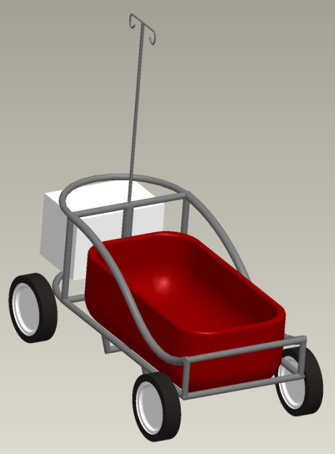
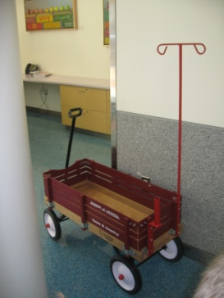
Phase 0

The Product Planning Process
The product planning process takes place before a product development project is formally approved and before any substantial resources have been expended on a project.
Product Planning Process: A 5-Step Process
The product planning process consists of the following 5 steps.
- Multiple opportunities are identified.
- These opportunities are prioritized and a portfolio of opportunities are selected.
- Resources are allocated
- A product plan is developed and a mission statement is crafted.
- Reflect on the planning process and begin the product development process for each selected opportunity.
Phase 0 - Step 1: Identifying Opportunities
The first step and, arguably the most difficult step, is identifying opportunities. In the corporate setting, these opportunities might be identified whom?
1.
2.
3.
4.
5.
6.
Byers (Table 2.1) lists the following categories of opportunity:
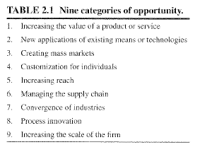
Exercise 0.2. Classify your proposed Venture Challenge Project as one of the categories of opportunities from Table 2.1:

Discontinuities, Trends and Convergence. Where do entrepreneurs find the opportunities?
Discontinuities. Byers suggests that one way to find opportunities is to look for discontinuities in culture, society or markets. Some examples of these sources of opportunity are listed in Table 2.2.
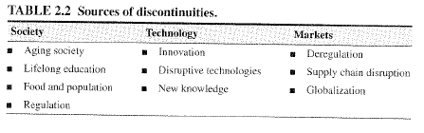
Trends. Trends in technologies and demographics can lead to large opportunities. The successful entrepreneur keeps an eye on trends in technologies and demographics and seeks opportunities that are responsive to these trends. Byers (Table 2.4) lists important social and cultural changes in demographics that are likely to be sources of opportunities in the future:



Convergence! Convergence of technologies or industries (i.e. merging of technologies or industries once thought to be separate) is another key source of opportunities. Recent examples of convergence:

The Opportunity Statement
Having identified a potential opportunity, it is useful to summarize it in single statement. An opportunity statement is a short sentence or statement that briefly captures a potential opportunity for a new product.
Example: Opportunity statement for the medwagon.

Exercise 0.3. Craft an Opportunity Statement for your proposed project.

Phase 0 - Step 2: Opportunity Evaluation
An attractive opportunity is one that is profitable to a new venture and valuable to the customers. Byers (Table 2.3) lists the following 5 characteristics of an attractive opportunity.

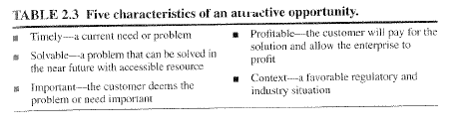

Although we will formalize a more thorough means of evaluating opportunities below, the characteristics in Table 2.3 should serve as a “go” vs. “no go” filter to weed out unattractive opportunities. Simply put, the successful entrepreneur seeks timely, solvable, important problems with a favorable context that can lead to profitability!

Exercise 0.4. Evaluate your Venture Challenge opportunity based on the 5 characteristics in Table 2.3. Does your proposed venture rate highly in each of the 5 characteristics? If not, do you still think that it is worthwhile pursuing?

To more formally evaluate opportunities, Byers (Table 2.7) outlines a basic 5-step process as follows:
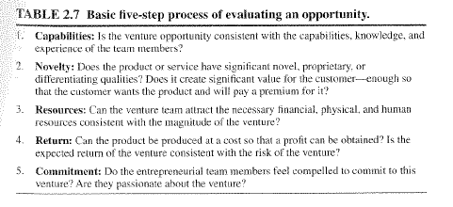
One means of capturing the quality of an opportunity with respect to the criteria above is the opportunity diamond shown in Figure 2.4 of Byers.
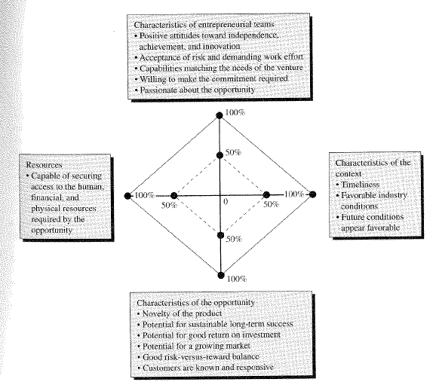
Exercise 0.5. Evaluate your Venture Challenge opportunity based on the 5 criteria in Table 2.7 and use Figure 2.4 of Byers to generate an opportunity diamond for your opportunity.

Phase 0. Step 3: Completing Project Planning: The Mission Statement
Once the project has been approved, but before substantial resources have been spent, the core team should meet again to complete pre-project planning activities. The output of these meetings should be a detailed mission statement.
The Mission Statement
The product vision statement is useful for keeping the team focused on the overall goal or vision of the new product. It does not, however, go into any specifics as to how the team is going to get there. To provide clearer guidance to the product development team, a mission statement should be crafted which includes the following:
- A brief, one-sentence description of the product (i.e. Opportunity Statement)–

- Key business goals –

- Target markets for the product –

- Assumptions and constraints –

  - Manufacturing –

  - Service –

  - Environmental issues –

- Stakeholders –
Exercise 0.6. Mission Statement.
Develop a mission statement for Venture Challenge Project.
Mission Statement:
Product Description:

Key business goals:

Primary Market:

Secondary Markets:

Assumptions:

Stakeholders:

The Value Proposition
Value is the worth, importance or usefulness to a customer. In business terms, value is the worth in monetary terms of the social and economic benefits that a customer receives from paying for a product or services. The value proposition is what defines the company to the customer. Most value propositions can be described by using the five key values summarized in Table 3.6 of Byers:
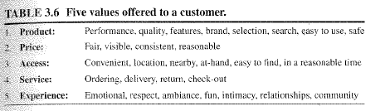
Crawford and Matthews (2001) suggest that a successful venture is one that is dominant in one of the above values, it must differentiate itself in a second value and it must meet the industry norms in the remaining three values. Considering a rating of 1 to 5, for example, the venture should have a score of 5, 4, 3, 3, 3.
Examples of successful value propositions:

Wal-Mart

Honda

Amazon.com

The Business Model
Once a value proposition has been clarified, a business must be designed that realizes the value proposition. A business design must answer three key questions: who is the customer, how are the needs of the customer satisfied and how are the profits captured and profitability protected? The outcome of the business design process is the business model.
A business model is a set of planned assumptions about how a firm will create value for all its stakeholders. It can also be thought of as a framework that connects your technology to economic profits.
Table 3.8 in Byers lists the elements of a business model:
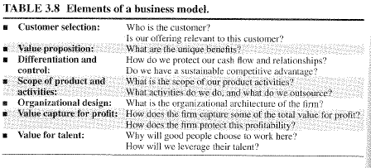
Example: The Dell Computer Business Model

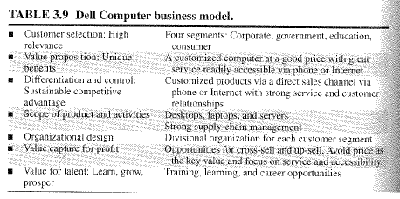

Venture Challenge Assignment # 2.
- Using the template in Exercise 0.6, create a mission statement for your proposed venture.
- Byers, page 50, Evaluate your venture challenge opportunity using the criteria in Table 2.7 and develop an opportunity diamond (Figure 2.4) based on this analysis.
- Byers, page 73, state the value proposition for your venture.
- Byers, page 73, create a draft business model for the venture using the elements of Table 3.8.

Identifying Customer Needs

Case Study: The Cordless Screwdriver
A successful hand tool company wanted to get into the business of cordless screwdrivers.
Result: After spending a lot of money developing several prototypes, they discovered during field testing that every prototype had features that customers did not like.
The problem: The development team did not know how to accurately identify customer needs.

Objectives of the Customer Needs Identification:
Recall that concept development is the 2nd phase of the product development process. The first step of the concept development phase is to identify customer needs. Here, we present a comprehensive method for identifying customer needs. The objectives of this method are as follows:
- Ensure that a product is developed by focusing on customer needs.
- Identify hidden needs as well as explicit needs.
- Provide a fact base for justifying product specifications.
- Create an archival record of the needs identification process.
- Ensure that no critical need is left out.
- Develop a common language of customer needs that all team members can understand: engineering, marketing, finance, etc.
Introduction
The overall philosophy is as follows:

.

The distinction between customer needs and product specs:
Customer Needs –

Product Spec –

Five Step Process
Identifying needs is a five step process:

Case Study:
The output of the project planning phase (Phase 0) is the product mission statement. For the cordless screwdriver project, the following mission statement was developed:

Mission Statement: Cordless Screwdriver Project
Product Description:
- A hand-held, power-assisted device for installing threaded fasteners.
Key business goals:
- Product introduced in fourth quarter of 2002
- 50% gross margin
- 10% share of cordless screwdriver market by 2004
Primary Market:
- Do-it-yourself consumer
Secondary Markets:
- Casual consumer
- Light-duty professional
Assumptions:
- Hand-held
- Power-assisted
- Nickel-metal-hydride rechargeable battery technology
Stakeholders:
- User
- Retailer
- Sales force
- Service Center
- Production
- Legal Department

Step 1. Gather Raw Data From Customers
The basic philosophy for developing quality products requires creating an information channel between the customer and the development team:
Three methods can be used to create this information channel:
- Interviews:

- Focus Groups:

- Observing the product in use:
Which method is best? In terms of bang for the buck, Griffin and Hauser (1993) have shown that two 1-hour interviews with two different customers can generate the same amount of data as one 2-hour focus group! See Exhibit 4-4 in Ulrich and Eppinger.

Eliciting Customer Needs Data. To elicit customer needs data, the following questions can be asked:
- When and why do you use this product?
- Walk us through a typical session of using this product.
- What do you like about the product?
- What do you dislike about the product?
- What issues do you consider when purchasing this product?
- What improvements would you make to this product?
The following hints are useful when conducting this type of interview:

Exercise 1.1. Documenting Customer Raw Data Statements. In this exercise, each team will be given a consumer product. Using the guidelines 1 through 6 above, 2 team members will interview the other team members using questions 1 through 6. Record the raw customer data statements in the middle column of the customer data template below:

Customer Data Template
Development Project:
Customer: Interviewer(s):
Address: Date:

Telephone: Currently uses:
Willing to do follow-up? Type of user:
Question/Prompt | Customer Statement | Interpreted Need
Typical uses
Likes – current product
Dislikes – current product
Suggested Improvements

Step 2. Interpret Raw Data in Terms of Customer Needs
Each statement in column 2 of the Customer Data Template can be interpreted as many different possible needs. How do you come up with the best possible need from a given customer statement?

In addition to this rule, the following guidelines can be used for translation from a customer statement into a customer need:
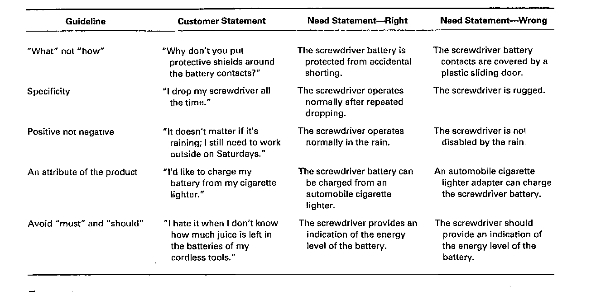

Case Study: The Cordless Screwdriver
For the cordless screw driver project, the following customer statements were generated from a particular customer.

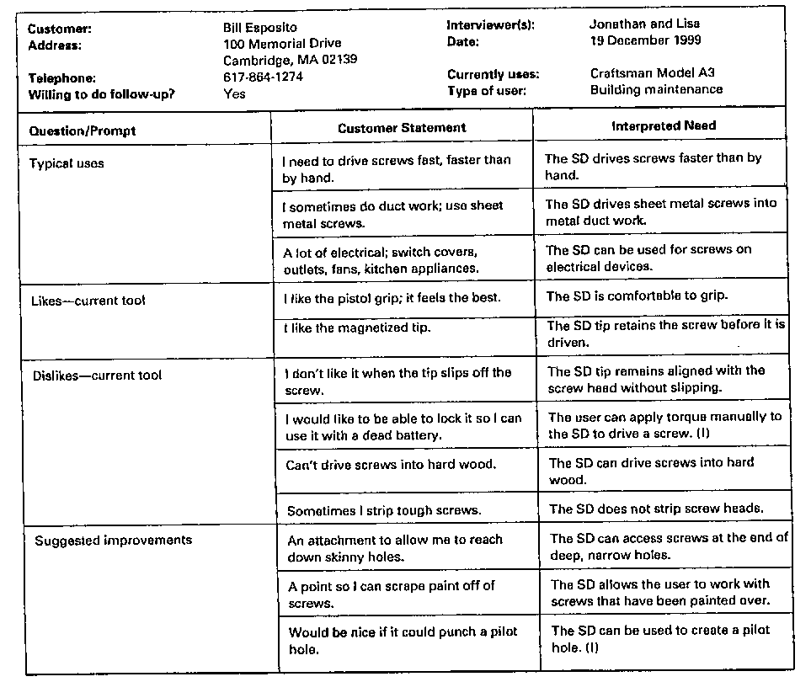

Exercise 1.2. Documenting Customer Raw Data Statements
Convert the raw customer data from exercise 1.1 into interpreted needs and summarize in the following table.
Customer Data Template
Development Project:
Customer: Interviewer(s):
Address: Date:

Telephone: Currently uses:
Willing to do follow-up? Type of user:
Question/Prompt | Customer Statement | Interpreted Need
Typical uses
Likes – current product
Dislikes – current product
Suggested Improvements

Phase 1. Concept Development
Step 2. Product Specifications

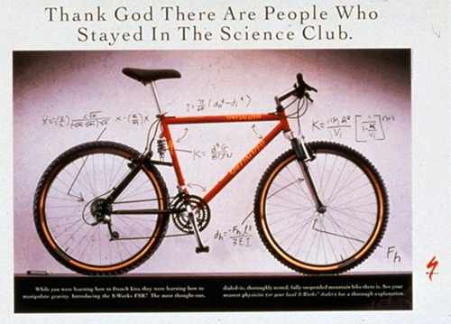
Case Study: Specialized Suspension Fork
In the mid 90’s, the Specialized bicycle company was interested in developing a new suspension fork for the recreational mountain bike cyclist. The company already produced a high-end suspension fork for racing cyclists who had less concern for cost or long-term durability (the attached figure is a 1993 advertisement for their first high-end bike with front and back suspension).
The company interviewed lead users (mountain bike racing cyclists), primary users (recreational cyclists on local trails) and other stakeholders (in-store dealers) to generate the following list of customer needs.
No |  | Need | Importance
1 | The suspension | reduces vibration to the hands. | 3
2 | The suspension | allows easy traversal of difficult terrain. | 2
3 | The suspension | enables high-speed descents on bumpy trails. | 5
7 | The suspension | is lightweight. | 4
8 | The suspension | provides stiff mounting points for the brakes. | 2
14 | The suspension | is not contaminated by water. | 5
Having generated a list of customer needs, the development team needed to:
- Translate subjective customer needs into precise target specifications
- Determine a measurement for success or failure of the development effort
- Determine whether their new product would capture a substantial share of the market.
- Resolve trade-offs such as cost and weight.
Why are specifications important?
Difference between Specifications and Needs
Customer needs are helpful in developing a clear sense of the issues of interest to the customer; however, they provide little specific guidance about how to design and engineer a product. To guide the engineering development effort, we must develop product specifications.
Product Specification:

Metric

Value

Target Specifications vs. Final Specifications
In an ideal world, a product development team would be able to generate a list of specs and build a product that meets those specs. However, for technology intensive products this is rarely possible. Generating, the process of generating specs is iterative, consisting of an initial set of target specifications, which are then refined into a set of final specifications.
Target Specifications

- .
Final Specifications

Establishing Target Specifications: 4-Step Process
Target specifications are established immediately after customer needs have been identified, but before any product concepts have been generated. As noted above, these target specs are what the development team wants to aim for, without regard to any constraints at this point.
Establishing target specs is a 4-step process:

Step 1: Preparing the List of Metrics
A good metric is one that reflects as directly as possible the degree to which a product satisfies a given customer need. Ideally, there would be only one metric for each need. In practice, this is rarely the case.

Case Study: Specialized Suspension Fork List of Metrics
The table below shows a list of 7 different metrics, along with the customer need that they address, their importance and the engineering units of the metric. The table is reproduced partially here.
Metric No. | Need Nos. | Metric | Imp. | Units
1 | 1, 3 | Attenuation from dropout to handlebar at 10 Hz. | 3 | dB
2 | 2, 6 | Spring preload | 3 | N
3 | 1, 3 | Maximum value from the “Monster” | 5 | G
4 | 1, 3 | Minimum descent time on test track | 5 | S
9 | 7 | Total Mass | 4 | Kg
17 | 12 | Instills pride | 5 | Subjective
19 | 14 | Time in spray chamber without water entry | 5 | S

Note the variety of different types of metrics in the above table.

Example 2.1 Develop a list of metrics for each interpreted need for your product.

List of Customer Needs:
No |  | Need | Importance
1
2
3
4
5
6
7
8
9
10

List of Metrics:
Metric No. | Need Nos. | Metric | Imp. | Units
1
2
3
4
5
6
7
8
9
10

The House of Quality
The House of Quality is a convenient way to represents the relationship between customer needs and metrics. The rows in the matrix correspond to customer needs and the columns correspond to metrics. A mark in one of the cells of the matrix means that the need and the metric are related. The “roof” of the House of Quality is used to document trade offs between metrics. Below is an example of a partial House of Quality for the suspension fork case study.

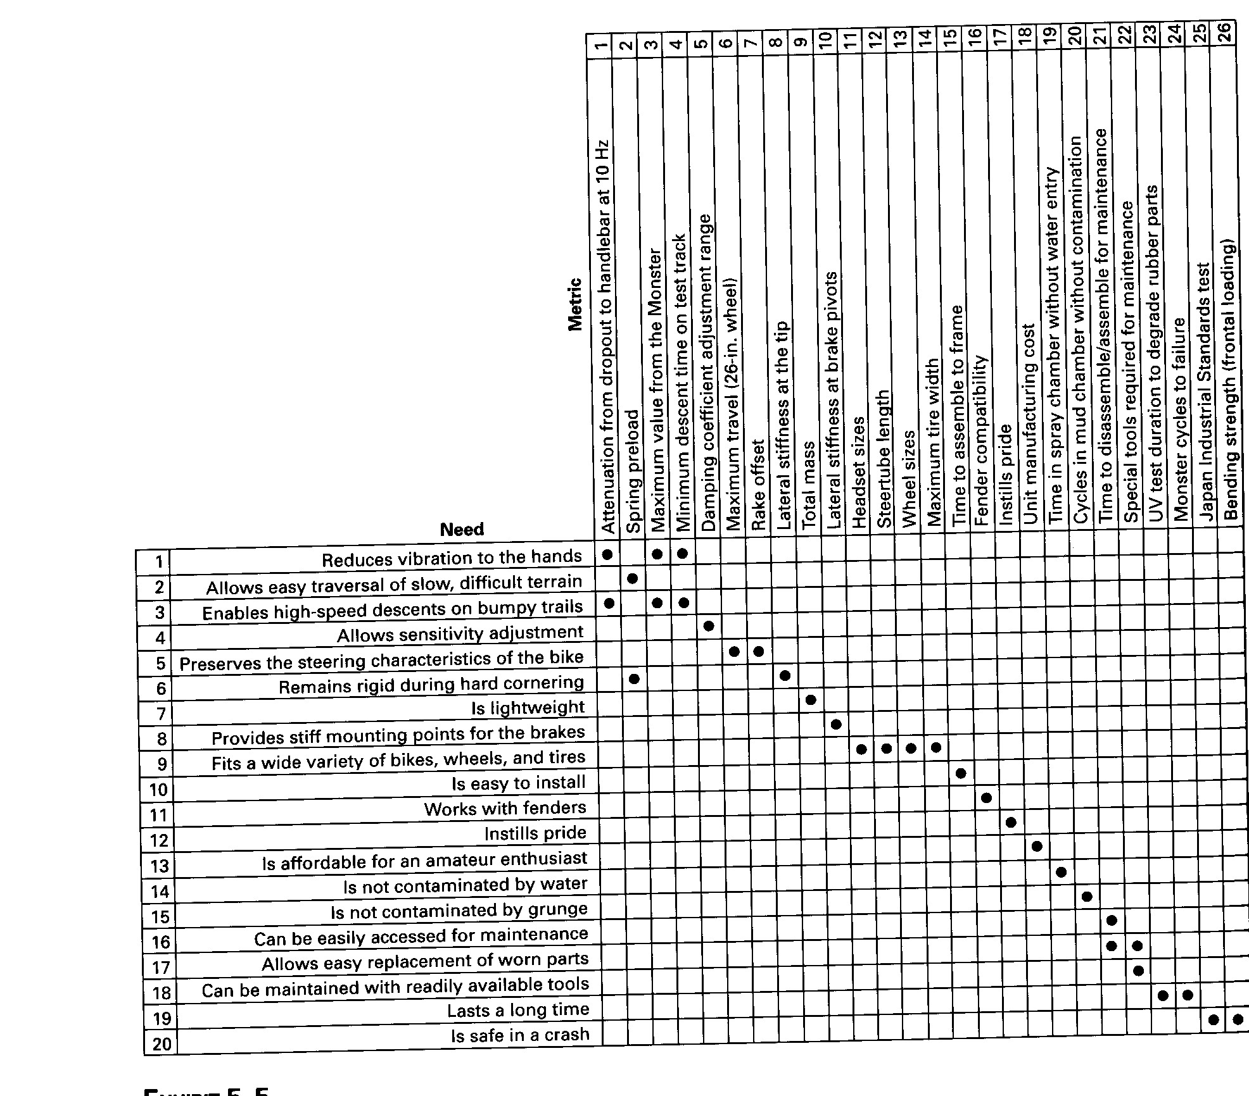
Step 2: Collect the Competitive Assessment Data
The relationship of a new product to competitive products is paramount in determining commercial success. In this regard, the target specifications are the language that a team uses to assess the new product relative to existing products, both its own and competitors.
Case Study: Competitive Benchmarking Chart for the Specialized Suspension Fork
An example of a competitive benchmarking chart is included in Exhibit 5-6. A portion of this chart is included below.
Metric No. | Need Nos. | Metric | Imp. | Units | ST Tritrack | Maniray 2 | Rox Tahx Quadra | Rox Tahx Ti21
1 | 1,3 | Attenuation from dropout to handlebar at 10 Hz | 3 | dB | 8 | 15 | 10 | 15
2 | 2,6 | Spring preload | 3 | N | 550 | 760 | 500 | 710
3 | 1,3 | Maximum value from the Monster | 5 | g | 3.6 | 3.2 | 3.7 | 3.3
4 | 1,3 | Minimum descent time on test track | 5 | s | 13 | 11.3 | 12.6 | 11.2
9 | 7 | Total mass | 4 | kg | 1.409 | 1.385 | 1.409 | 1.364
18 | 13 | Unit manufacturing cost | 5 | US$ | 65 | 105 | 85 | 115
19 | 14 | Time in spray chamber without water entry | 5 | s | 1300 | 2900 | >3600 | >3600

Step 3: Set Ideal and Marginally Acceptable Target Values for Each Metric
Once all of the competitive assessment data is taken, the team then puts together the target values for each metric. This list contains two types of target values:

The target specs (both the ideal and marginal) are created by the development team by:

Case Study: Target Specification Chart for the Specialized Suspension Fork
Exhibit 5-8 (reproduced partially below) shows the Target Spec Chart for the Specialized suspension fork project. Note that both the marginal and ideal values of each metric are included.
Metric No. | Need Nos. | Metric | Imp. | Units | Marginal Value | Ideal Value
1 | 1,3 | Attenuation from dropout to handlebar at 10 Hz | 3 | dB | >10 | >15
2 | 2,6 | Spring preload | 3 | N | 480-800 | 650-700
3 | 1,3 | Maximum value from the Monster | 5 | g | < 3.5 | <3.2
4 | 1,3 | Minimum descent time on test track | 5 | s | < 13.0 | < 11.0
9 | 7 | Total mass | 4 | kg | < 1.4 | < 1.1
18 | 13 | Unit manufacturing cost | 5 | US$ | < 65 | < 65
19 | 14 | Time in spray chamber without water entry | 5 | s | > 2300 | > 3600

Note: The goal of this step in the product development process is to establish the boundaries of the competitively viable product space.
At this point in the development process, the team hopes that the product will meet some of the ideal target specs, but should also be confident that a product can be commercially viable even if it exhibits one or more marginally acceptable metric values.

