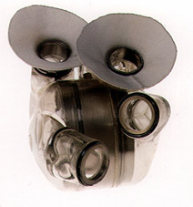

Syllabus

Course: Thermodynamics, MECH 337
Meeting times: MWF 2:00-2:50 p.m. (Clark A 207)
W 3:00-3:50 p.m. (Clark A207)
Instructor: Prof. Anthony J. Marchese
marchese@colostate.edu
Office: ENG A103H
Phone: 1-2328
AbioCor™ Implantable Replacement Heart.
Instructor Office Hours: Mon. 12:00 p.m. to 1 p.m.
Wed. 12:00 p.m. to 1 p.m.
Teaching Assistant: Esteban Hincapie
esteban.hincapie@gmail.com
Office: A103N
TA Office Hours: Monday and Wednesday, 10 a.m. to 12 p.m.

Textbook: Fundamentals of Engineering Thermodynamics, 7th Edition, Moran and Shapiro, 2010, Wiley.
Course Description
This course will provide an introduction to the basic concepts of properties and states of a substance, equilibrium, energy, entropy, processes and cycles. We will apply these principles toward the analysis of engineering systems such as engines, compressors, pumps, steam plants, and thermodynamic cycles for power generation and refrigeration.
Course Objectives
Upon successful completion of this course, each student will be able to:
- Explain the concepts of properties and states of a substance, energy, entropy, processes and cycles; and the laws of thermodynamics.
- Write down the equations for the first and second laws of thermodynamics and explain the meaning of each term.
- Calculate PdV work for a closed system undergoing quasi-equilibrium process.
- Determine the thermodynamic properties for any ideal gas or pure substance.
- Apply the first law of thermodynamics to any closed system or control volume.
- Apply the second law of thermodynamics to the analysis of any engineering system or control volume.
- Apply the first and second laws of thermodynamics to the analysis of complex gas and vapor power systems and refrigeration systems.
- Perform humid air calculations toward the solution of a variety of HVAC problems.
- Recognize how the principles of thermodynamics apply toward the design and operation of familiar products and processes.

Grading Policy
Homework/Quizzes (30%). Approximately 5 to 8 homework problems per week will be assigned. Ten-minute, in-class quizzes will be given on the day that homework is due; In-class “design of the week” assignments will be given at random.
Exam #1 (20%). A 1.5-hour examination will be given at approximately the 6th week of class. Exam 1 is closed book, but a 1-page cheat sheet is permitted.
Exam #2 (20%). A 1.5-hour examination will be given at approximately the 12th week of class. Exam 2 is closed book, but a 1-page cheat sheet is permitted.
Final Exam (30%). A 2-hour comprehensive final exam will be given during finals week. The final exam is closed book, but two 1-page cheat sheets are permitted.
Grading Rubric
Final grades will be assigned based on your overall final score on a scale of 0 to 100 points as follows:
A+ > 97
A 92 to 96.9
A- 90 to 91.9
B+ 87 to 89.9
B 82 to 86.9
B- 80 to 81.9
C+ 77 to 79.9
C 69.9 to 76.9
D 60 to 69.8
F < 59.9
Homework Format and Grading
Approximately 5 to 8 problems will be assigned each week and 2 to 3 problems will be graded in detail at random. 20 % of each homework grade will be based on your having attempted all problems. 80% of the homework grade will be based on the graded problems. Assignments are due at the beginning of the class on the day announced by the instructor. Late assignments will not be collected (Late = 0), but the lowest homework grade will be dropped.
Assignments must be done on engineering paper in the format specified by the instructor (Known, Find, Given, Schematic Diagram, Engineering Model, Analysis). A sample of the required format is attached.
Attendance and Lateness Policy
Attendance at all lectures and recitations is mandatory. Note that in-class quizzes will be given on days when homework is due and “design of the week” assignments can be given during any lecture. Sleeping in class is forbidden. Notebooks and calculators should be brought to each class. Please turn off your cell phones. If you have an emergency situation where your phone needs to be left on, please alert me prior to class…and please put it on vibrate. Class begins promptly at 2:00 p.m.; please do not be late!
Course Website
Information on this class (including this syllabus) will be posted on the web at: http://www.engr.colostate.edu/~marchese/mech337-12

Academic Integrity Policy

All Mechanical Engineering students are required to adhere to the Policies and Guiding Principles (section 1.6 of the CSU general catalog) governing student conduct, and the Mechanical Engineering Student Academic Integrity Policy (on the Current Students page of the ME web site). Please review both links.

The Mechanical Engineering Academic Integrity Policy is also available on the course website:
http://www.engr.colostate.edu/~marchese/mech337-12/academic-integrity.doc

Week | Date(s) | Text | Topics | Homework
1 | Aug. 20  Aug. 22  Aug. 24 | Ch. 1 | Introductory Concepts and Definitions | Problems:  Date Due:
2 | Aug. 27  Aug. 29  Aug. 31 | Ch. 2 | Energy and the First Law of Thermodynamics | Problems:  Date Due:
3 | Sep. 5  Sep. 7 | Ch. 3 | Evaluating Thermodynamic Properties | Problems:  Date Due:
4 | Sep. 10  Sep. 12  Sep. 14 | Ch.3 |  | Problems:  Date Due:
5 | Sep. 17  Sep. 19  Sep. 21 | Ch. 4 | Control Volume Energy Analysis | Problems:  Date Due:
6 | Sep. 24  Sep. 26  Sep. 28 | Ch. 5 | The Second Law of Thermodynamics | Problems:  Date Due:
7 | Oct. 1  Oct. 3  Oct. 5 | Ch. 6 | Defining entropy change, entropy balances for closed systems  Exam #1 (approx. date) | Problems:  Date Due:
8 | Oct. 8  Oct. 10  Oct. 12 | Ch. 6 | Entropy balances for open systems, isentropic efficiency | Problems:  Date Due:
9 | Oct. 15  Oct. 17  Oct. 19 | Ch. 8 | Vapor Power Systems | Problems:  Date Due:
10 | Oct. 22  Oct. 24  Oct. 26 | Ch. 8 | Vapor Power Systems | Problems:  Date Due:
11 | Oct. 29  Oct. 31  Nov. 2 | Ch. 9 | Gas Power Systems | Problems:  Date Due:
12 | Nov. 5  Nov. 7  Nov. 9 | Ch. 9 | Gas Power Systems | Problems:  Date Due:
13 | Nov. 12  Nov. 14  Nov. 16 | Ch. 10 | Refrigeration and Heat Pump Systems  Exam #2 (approx. date) | Problems:  Date Due:
14 | Nov. 19-23 |  | Fall Break
15 | Nov. 26  Nov. 28  Nov. 30 | Ch. 12 | Ideal Gas Mixtures and Humid Air Calculations (Psychrometrics) | Problems:  Date Due:
16 | Dec. 3  Dec. 5  Dec. 7 | Ch. 13 | Reacting Mixtures and Combustion | Problems:  Date Due:
17 | Dec. 12-16 |  | Final Exam (Date TBD)

Example Homework Problem and Solution Technique

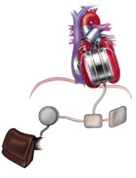
Raw Problem Statement. One of the design requirements of an artificial heart under development is that the blood temperature does not increase by more than .01 °C as it is pumped through the heart. It is known that the pressure rise required for the heart pump is 120 mm Hg and that the average flow rate required is 5 liter/min. Assuming that the electrical and mechanical losses result in a pump efficiency of 25%, estimate the rate of heat removal in Watts required to maintain the allowable temperature increase.

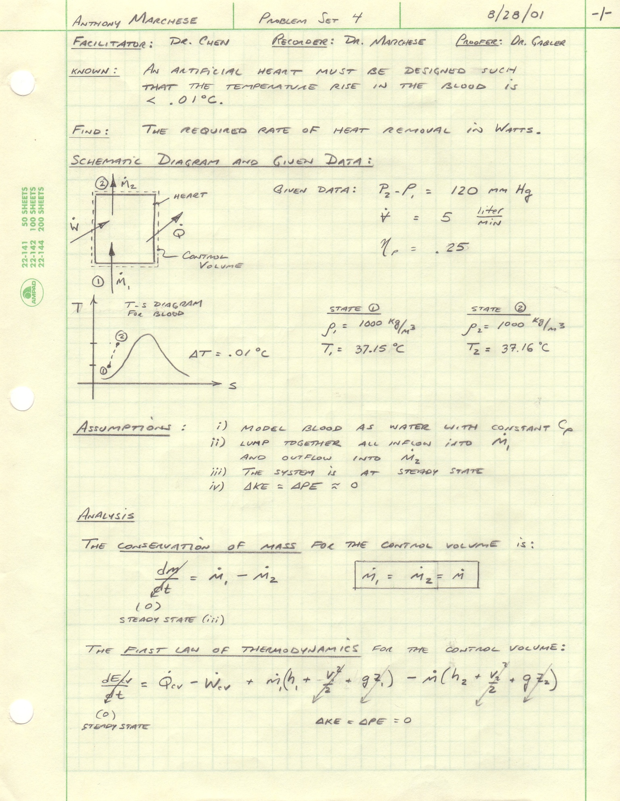
Serial Number
Date
Collaborators:
Engineering Model:
Name

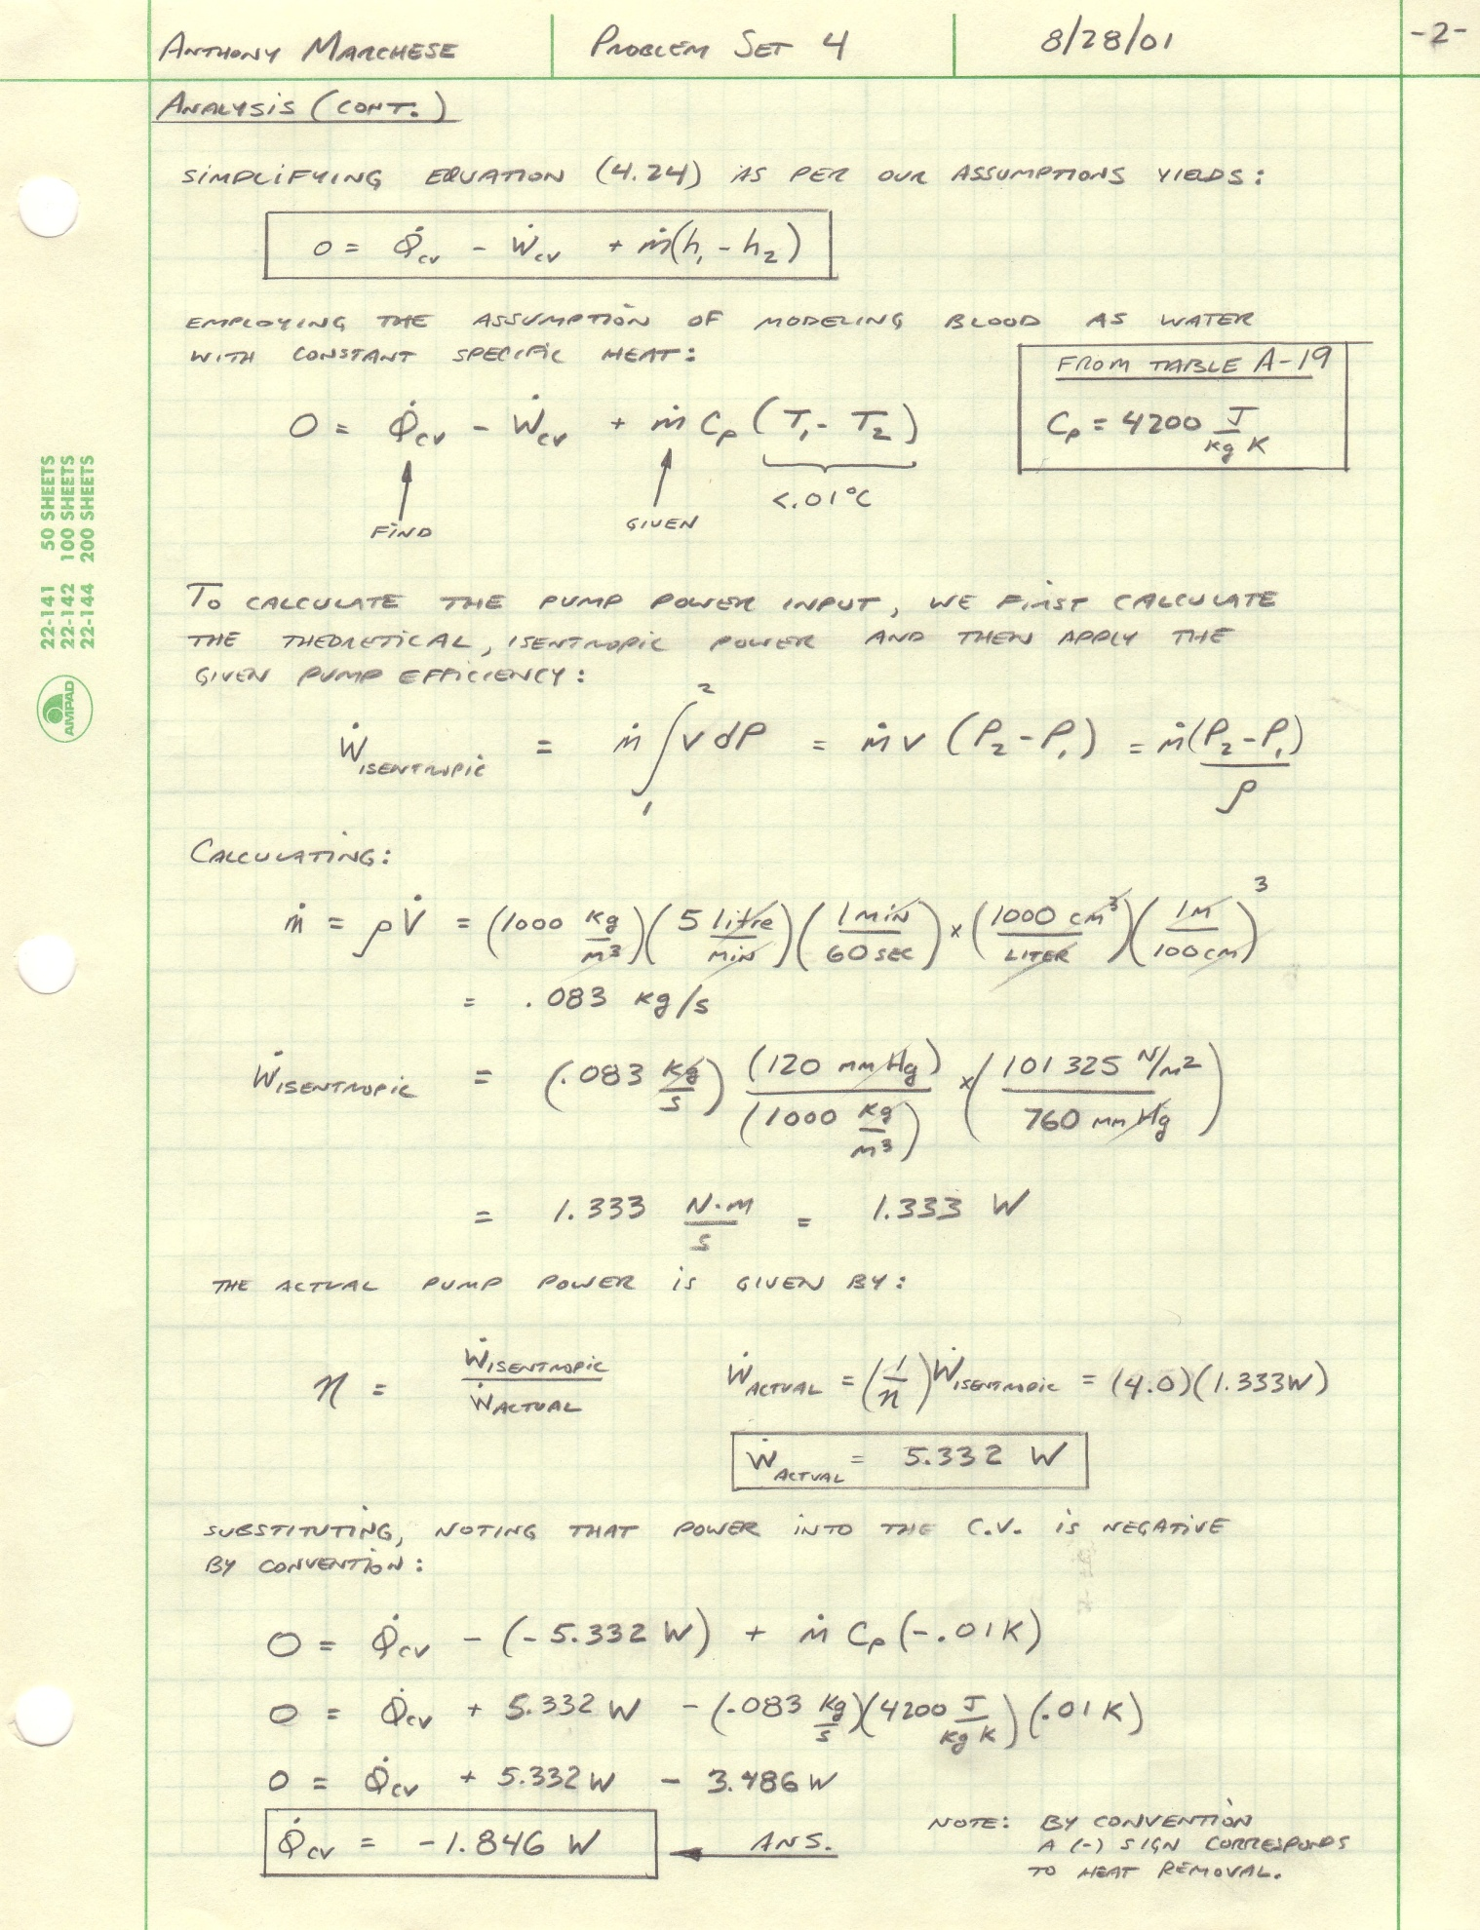
Name
Date

