Technical Objectives:
- Develop and analyze thermodynamic models of vapor-compression refrigeration and heat pump systems including sketching the cycles on T-s and P-h diagrams.
- Evaluate property data, apply mass, energy and entropy balances for each component and determine system performance (coefficient of performance, EER, capacity).
- Explain the effects of varying system parameters on overall system performance.
HW (Due Date: Wed, Dec. 5): 10.8, 10.10, 10.15, 10.24, 10.34, 10.42

1. Background: The Vapor Compression Refrigeration Cycle
Virtually all refrigerators, residential air conditioning systems (window units, central air conditioning systems and split systems) and automotive air conditioning systems operate on the simple vapor compression refrigeration cycle.
The basic components of a vapor compression refrigeration system are shown below:

The working fluid in a vapor compressor refrigeration system is called a “refrigerant” which is chosen because of its Pressure-Temperature characteristics based on the particular application (air conditioning vs. refrigeration).
All vapor compression refrigeration systems include the following 4 components:
Compressor:

Condenser:

Expansion Valve:

Evaporator:

1.1 Applications of the Vapor Compression Refrigeration Cycle
The same basic cycle shown on page 1 is used for refrigerators (household, commercial, retail), air conditioning systems (residential, automotive) and heat pumps. The only major difference in most of these applications is the temperature and location of the T_{hot,res} and T_{cold,res}
Residential Air Conditioning System (Central Air)

Residential Heat Pump

Household Refrigerator

2. Analyzing Vapor-Compression Refrigeration Cycles
In a manner that is analogous to the Rankine Cycle, each component in the Vapor Compression Refrigeration Cycle can be analyzed using the steady state first law analysis for an open system. Once again, we will depart from our sign convention and define all work and heat transfer as positive in the direction shown in the figure on page 1.
Compressor:

(10.4)

Condenser

(10.5)

Expansion Valve: Assuming that heat transfer is negligible, analysis of the expansion valve results in the familiar throttling process.

(10.6)

Evaporator:

(10.3)

For a refrigerator or an air conditioner, the term 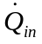is called the refrigeration capacity, which we typically measure in units of BTU/hr or “tons”. 1 ton of refrigeration capacity = 12,000 BTU/hr.

2.1 Coefficient of Performance for Refrigeration and Air Conditioning
For an air conditioning system or refrigeration system, the useful energy is and the energy that costs money is the power input to the compressor (some systems might also require other sources of power such as condenser fans and control systems). For now, assuming that the only power input is the compressor, we can define coefficient of performance as:

(10.7)
For consumer appliances, we usually use the term Energy Efficiency Ratio, which is basically a coefficient of performance in mixed units:

(10.7a)

2.2 Coefficient of Performance for a Heat Pump
For a heat pump, the useful energy is the heat transfer out of the condenser, 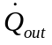. In this case, the coefficient of performance is:

(10.10)

3. The Ideal Vapor Compression Refrigeration Cycle
Analogous to the Rankine Cycle, it is useful to first determine the performance of an ideal refrigeration cycle. The Ideal Vapor Compression Cycle uses the following assumptions:
T_{HOT,RES} ≈ T_{SAT, CON}

T_{COLD,RES} ≈ T_{SAT, EVAP}

Compressor is modeled as adiabatic and internally reversible

No pressure drop in the condenser or evaporator.

With these assumptions, the Ideal Vapor Compression Cycle is as follows:
Process 1-2

Process 2-3

Process 3-4

Process 4-1

The process is shown below on a T-s diagram and a P-h diagram. In practice, P-h diagrams are used more often in the air conditioning industry. Since enthalpy is related directly to the cooling capacity and compressor power, the P-h diagram is a more effective graphical tool to visualize the process than a T-s diagram.
T-s Diagram P-h diagram

A real P-h diagram for R134a is shown below:
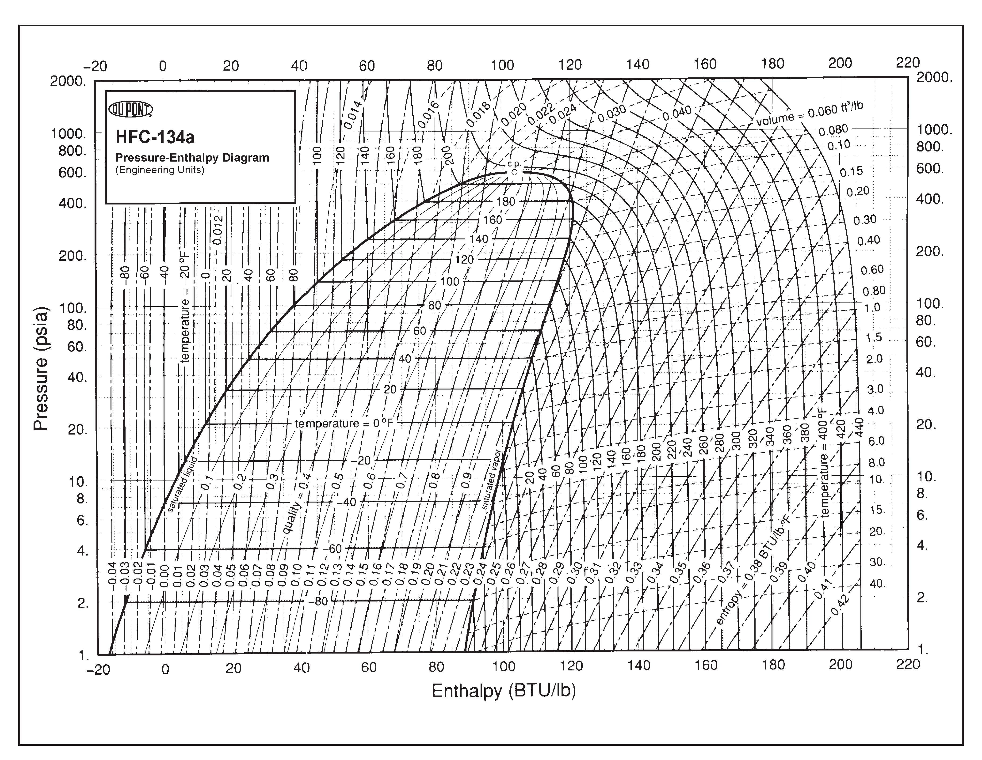

Example 1. The Ideal Vapor Compression Refrigeration Cycle.
Known: R22 is the working fluid for a central air conditioning system which is being designed to cool an entire house to 65 °F when it is 100 °F outside. It is known that the refrigeration capacity necessary to cool the house under these conditions is 36,000 btu/hr.
Find: Using the ideal vapor compression refrigeration cycle, determine: (a) the maximum possible coefficient of performance and EER (BTU/W-hr) of this cycle, (b) the refrigerant flow rate (lb/hr) (c) the power input requirement for the compressor (W) and (d) compare the EER of this cycle to that of the Carnot refrigeration cycle (eq. 5.10).
Schematic Diagram and Given Data:

Engineering Model:

Analysis

4. Actual Vapor Compression Refrigeration Cycle
Real vapor compression refrigeration cycles deviate from the ideal cycle in the following ways:

A real vapor compression refrigeration cycle is shown below on T-s and P-h diagrams, respectively:
T-s Diagram P-h diagram

Example 2. Real Vapor Compression Refrigeration Cycle
Known: R22 is the working fluid for an actual central air conditioning system which is designed to cool an entire house to 65 °F when it is 100 °F outside. In order to accomplish this goal, the saturated condenser temperature must be 130 °F and the saturated evaporator temperature must be 45 °F. The measured compressor power under these conditions is 3360 W and the measured mass flow rate is 526 lbm/hr. The temperature at the compressor inlet and discharge is 65 °F and 204 °F, respectively.
Find: (a) the actual coefficient of performance and EER (BTU/W-hr) of this cycle, (b) the cooling capacity (btu/hr) (c) compare the EER of this cycle to that of the ideal vapor compression refrigeration cycle and the Carnot refrigeration cycle (eq. 5.10).
Schematic Diagram and Given Data:

Engineering Model: Assume no pressure drop in condenser and evaporator. Also, assume that the refrigerant exits the condenser as a saturated liquid.

Analysis:
Example 3. Vapor Compression Heat Pump
Known: An office building requires a heat transfer rate of 20 kW to maintain the interior temperature at 21 °C when the outside temperature is 0°C. A vapor-compression heat pump with R134a is to be used to provide the space heating. The compressor operates adiabatically with an isentropic efficiency of 82%. To provide effective heat transfer in the evaporator and condenser a ΔT of 10 °C is required between the ambient air and the working fluid in both devices. Assume that the R134a exits the evaporator as a saturated vapor and exits the condenser as a saturated liquid.
Find: (a) the mass flow rate of the refrigerant (kg/s), (b) the compressor power (kW) and (c) the coefficient of performance and compare this efficiency to that of the Carnot Cycle operating between the inside and outside temperatures.
Schematic Diagram and Given Data:

Engineering Model:

Analysis:

