Technical Objectives:
- Explain (to a high school sophomore) the concepts of Energy and Work and the common forms in which they exist.
- Calculate PdV work for a closed system undergoing a quasi-equilibrium process.
- Explain (to a high school sophomore) each term in the First Law of Thermodynamics equation for a closed system.
- Apply the First Law of Thermodynamics to a closed system as it undergoes a process from an initial to a final equilibrium state, which may or may not be a cycle.
- Define and evaluate the thermodynamic efficiency (or coefficient of performance) for a power cycle, refrigeration cycle or heat pump cycle.
HW (Due Date: September 7): 2.22, 2.24, 2.28, 2.56, 2.63, 2.69, 2.73, 2.87,2.89
1. Introduction: Energy and Closed Systems. Consider the following closed system:

In addition to its temperature and pressure, energy is also a property of a system. Energy has the following engineering units:

Energy Storage -
Energy Transfer -
Energy Conservation -
  - Forms of Energy Storage. Consider the following closed system, traveling at a velocity, v, at a height above sea level of z and at a temperature, T.

At this instant in time, the closed system is storing energy in the form of kinetic, potential and internal energy.
Kinetic Energy
Kinetic Energy is a function of the closed system’s bulk velocity according to the following relationship:
(2.5a)
Potential Energy
Potential Energy is a function of the closed system’s height above sea level according to the following relationship:

(2.10a)

Internal Energy
Internal Energy is the energy stored within the molecules of the system. It is related to the temperature, which is related to the random motion of the molecules:
Extensive property Intensive property

  - Changes in Energy
Consider again the above closed system. What are the changes in energy after the system undergoes a process from an equilibrium state (1) to new equilibrium state (2)?
State 1 State 2

Change in Kinetic Energy

(2.5)

Change in Potential Energy

(2.10)

Change in Internal Energy

Total Energy Change
For a closed system undergoing a change from an equilibrium state (1) to a new equilibrium state (2), the total energy change is:

(2.27)

2. Relationship Between Work and Energy
Equation (2.27) shows that energy (a property) can change for a closed system. But it does not say anything about what causes a closed system to change its state. What can be done to a closed system to make it change its state? Answer:

2.1 Show Mathematically that Work Results in a Change in Energy
Consider the following system of mass, m, being accelerated by an external force F:

Newton’s second law of motion can be written as follows:

Integrating from equilibrium state (1) to equilibrium state (2):

(2.6, 2.12)

This equation shows that an input of mechanical work, results in a change in kinetic energy!
Do work and kinetic energy have equivalent units?

3. Expansion and Compression Work
Since gases can expand, they can do useful work for us. And, since they can compress, we can do work on a gas. Consider the following system of gas, in a cylinder:
State (1) State (2)

The work done by the system on the rest of the universe can be evaluated by evaluating the left side of equation 2.4:

But, at any instant in time as the system changes from state 1 to state2, a free body diagram of the piston shows that:

Substituting into the above equation:

(2.17)

This equation is valid for any system undergoing a change from one volume to another provided you can evaluate the integral! In other words, you need to know how the pressure in the cylinder varies as a function of the cylinder volume.
3.1 Sign Convention
Keeping track of whether work is positive or negative is key in thermodynamics. The following sign convention must be used:
If work is done by the system:

If work is done on the system:

3.2 Evaluating PdV Work from Equation 2.17
Consider again the piston-cylinder as it changes in volume from equilibrium state (1) to equilibrium state (2):

Equation 2.17 suggests that the work done by the gas is the area under the P-V curve:

(2.17)

However, to evaluate this integral we must know how P and V relate for every point in between states 1 and 2.
3.3 The Concept of a Quasi-Equilibrium Process (Revisited)
A quasi-equilibrium process is one in which we can uniquely define the thermodynamic state for all points on the PV curve between states 1 and 2. If the piston moves slow enough, we can accurately model the compression or expansion process as a quasiequlibrium process.
How slow is slow enough? Are the pistons in your automobile engine slow enough?

3.4 Examples of Processes for which the integral 2.17 can be evaluated:
Isobaric Process

Polytropic Process

Isothermal Process

Experimental Evaluation of PV Diagram

Example 2.1 Isobaric Expansion
Known: A gas in a piston-cylinder device undergoes a process from state 1 to state 2. Pressure is constant at 300 kPa.
Find: The work in Joules.
Given: Initial piston volume is 0.01 m³. Final volume is 0.02 m³
Schematic Diagram: Assumptions:

Analysis:

Example 2.2 Isothermal Expansion of an Ideal Gas
Known: A gas in a piston-cylinder device undergoes a process from state 1 to state 2. Temperature is constant.
Find: a) The work in Joules. b) The final pressure in kPa.
Given: Initial piston volume is 0.01 m³. Final volume is 0.02 m³. The initial pressure is 300 kPa.
Schematic Diagram: Assumptions:

Analysis:

Example 2.3 Polytropic Expansion (PV^{n} = Constant)
Known: A gas in a piston-cylinder device undergoes a polytropic process from state 1 to state 2. Temperature is constant.
Find: a) The work in Joules. b) The final pressure in kPa.
Given: Initial piston volume is 0.01 m³. Final volume is 0.02 m³. The initial pressure is 300 kPa. The polytropic exponent is 1.4.
Schematic Diagram: Assumptions:

Analysis:

4. Heat
We have already shown that doing work on a system results in a change in energy (eqn. 2.4). A second form of energy transfer is heat. Consider the following thermodynamic system undergoing a process from equilibrium state 1 to 2:

If heat is added to the system during process 1-2:

If heat is rejected from the system during process 1-2

If no heat is transferred during process 1-2.

Notes:

4.1 Rate of Heat Transfer
In engineering practice, we are often interested in the instantaneous rate of heat transfer:

The rate of heat transfer has units of:
4.2 Modes of Heat Transfer
Recall from the first day of class that we cannot use thermodynamics alone to determine the rate of heat transfer. It is, however, useful to introduce the various modes in which heat can be transferred to and from a system: conduction, convection and radiation.
Conduction Convection

Radiation

5. The First Law of Thermodynamics for a Closed System
Consider the following closed system into which a quantity of heat, Q, is transferred and which does an amount of work, W, on the surroundings during a process 1-2.

The first law of thermodynamics for a closed system (or the conservation of energy) can be stated as follows:

In mathematical form this can be expressed as:

(2.35a)

(2.35b)

The first law of thermo can also be expressed as a rate equation:

(2.37)

Example 2.4
Known: 5 kg of steam is contained in a piston-cylinder assembly. During a process, 80 kJ of heat is added to the system and an electric mixer does 18.5 kJ of work on the system. The specific internal energy of the steam increases from 2660 kJ/kg to 2710 kJ/kg.
Find: The amount of work done on the system or by the system (kJ)
Schematic Diagram and Given Data:

Assumptions:

Analysis:

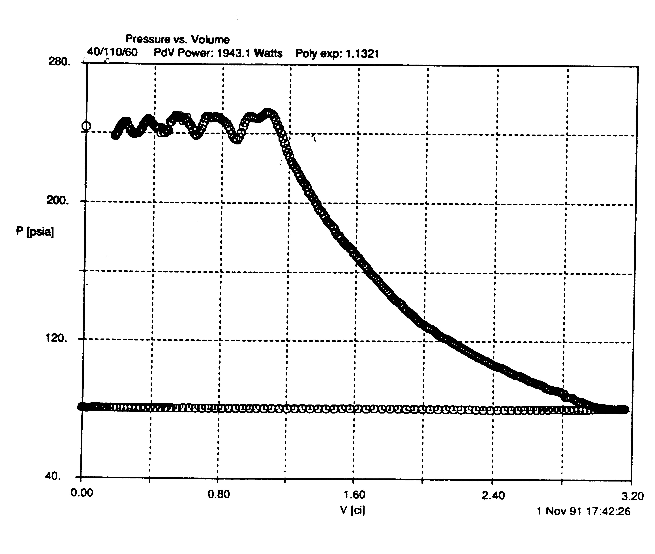
Example 2.5

1
2

Known: A scroll compressor is instrumented with pressure transducers to generate the above plot of pressure vs. volume for a single pocket of gas. The polytropic exponent was measured to be 1.175. Based on the temperatures and pressures at the inlet and exit, the specific internal energy, u, at each state is known to be 234.9 kJ/kg to 267.5 kJ/kg, respectively. Also, based on the pressure, temperature and volume at state 1, it is known that each compression pocket contains 0.0012 kg of refrigerant. The compressor operates at 3529 RPM. The measured electrical input to the compressor is 2720 Watts.
Find: a) The pdV work per compressor revolution [J/rev]. B) The PdV power in [W] and compare this to the measured compressor electrical power. c) Find the heat transfer into or out of the compression pockets per compressor revolution [J/rev].
Schematic Diagram and Given Data:

Assumptions:

Analysis:

5.2 The First Law of Thermodynamics for a Cycle
Since energy is a thermodynamic property, if a system undergoes a cycle it must have the same energy in the beginning of the cycle as the end of the cycle. Therefore, evaluating 2.35a for a cycle results in the following:
(2.40)
5.3 Power Cycles. A system operating under a power cycle generates power by accepting heat addition from a hot reservoir and rejecting heat to a cold reservoir:

The net work produced by a system undergoing a power cycle is, therefore, as follows (note that we depart from our sign convention for work and heat here!):
(2.41)
5.3.1 Thermodynamic Efficiency of a Power Cycle
By definition, thermodynamic efficiency is always defined as useful energy, divided by energy that we have to pay for:

Thus, for a power cycle, we can define thermodynamic efficiency as follows:
(2.42, 2.43)

5.4 Refrigeration Cycles
A system operating under a refrigeration cycle accepts heat from a cold reservoir and rejects it to a hot reservoir through the addition of work:

The work required for a refrigeration cycle is therefore:

(2.44)

The above cycle can be used to provide cooling or heating. If the goal is to provide cooling to a cold reservoir, the useful energy is Q_{in} and the system would be called a refrigerator or air conditioner, depending on the application. If the goal is to provide heating, then the useful energy would be Q_{out} and the system would be called a heat pump.
5.4.1. Coefficient of Performance (COP). For refrigeration systems (and heat pumps), we use the terminology “coefficient of performance” to describe the thermodynamic efficiency, but we still define it as useful energy divided by that energy which costs money.
COP for a Refrigeration Cycle

(2.45, 2.46)

COP for a Heat Pump

(2.47, 2.48)

Example 2.6. Example of First Law for a Closed System Undergoing a Cycle
Known: A gas within a piston-cylinder assembly undergoes a thermodynamic cycle consisting of three processes. Process 1-2 is a constant volume process for which V = 0.028 m³ and U₂ – U₁ is 26.4 kJ. Process 2-3 is an expansion in which pV = constant and U₃ = U₂. Process 3-1 is a constant pressure process during which p = 1.4 bar and W₃₁ is -10.5 kJ. There are no significant changes in potential energy or kinetic energy during any of the processes.
Find: a) sketch the process on a p-V diagram
b) calculate the net work for the cycle [kJ].
c) calculate the heat transfer for process 2-3 [kJ].
d) calculate the heat transfer for process 3-1 [kJ]
e) is this a power cycle or refrigeration cycle?
Schematic Diagram and Given Data:

Assumptions:

Analysis:

