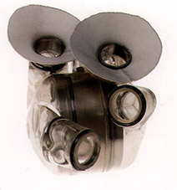

Syllabus

Course: Thermodynamics, MECH 337
Meeting times: MWF 2:00-2:50 p.m. (Clark A 207)
Th 12:00-12:50 p.m. (Clark A104)
Instructor: Dr. Anthony J. Marchese Office: Eng A103H
marchese@colostate.edu Phone: 1-2328
Instructor Office Hours: Mon. 10:00 a.m. to 11 a.m.
Wed. 10:00 a.m. to 11 a.m.
AbioCor™ Implantable Replacement Heart.
Teaching Assistant: Khandakar “Niaz” Morshed
khandakar.morshed@colostate.edu
Textbook: Fundamentals of Engineering Thermodynamics, 6th Edition, Moran and Shapiro, 2008, Wiley.
Course Description: This course will provide an introduction to the basic concepts of properties and states of a substance, equilibrium, energy, entropy, processes and cycles. We will apply these principles toward the analysis of engineering systems such as engines, compressors, pumps, steam plants, and thermodynamic cycles for power generation and refrigeration.
Grading Policy:
Homework/Quizzes (30%). Approximately 5 to 8 homework problems per week will be assigned. Assignments must be done on engineering paper in the format specified by the instructor (Known, Find, Given, Schematic Diagram, Analysis). A sample of the required format is attached. Assignments are due at the beginning of the class on the day announced by the instructor. Late assignments will not be collected (Late = 0), but the lowest homework grade will be dropped.
Exam #1 (20%). A 1.5-hour examination will be given at approximately the 6th week of class. Exam 1 is closed book, but a 1-page cheat sheet is permitted.
Exam #2 (20%). A 1.5-hour examination will be given at approximately the 12th week of class. Exam 2 is closed book, but a 1-page cheat sheet is permitted.
Final Exam (30%). A 2-hour comprehensive final exam will be given during finals week. The final exam is closed book, but two 1-page cheat sheets are permitted.
Homework Grading Policy
Approximately 5 to 8 problems will be assigned each week. 2 to 3 problems will be graded in detail at random. 20 % of each homework grade will be based on your having attempted all problems. 80% of the homework grade will be based on the graded problems.
Attendance and Lateness Policy
Attendance at all lectures and recitations is mandatory. Note that in-class quizzes will be given on days when homework is due. Sleeping in class is forbidden. Notebooks and calculators should be brought to each class. Please turn off your cell phones. If you have an emergency situation where your phone needs to be left on, please alert me prior to class…and please put it on vibrate. Just so you know, lateness is one of my pet peeves…please be mindful that class begins promptly at 2:00 p.m. (noon on Thursdays).
Course Website.
Information on this class (including this syllabus) will be posted on the web at: http://www.engr.colostate.edu/~marchese/mech337-10

Week | Date(s) | Text | Topics | Homework
1 | Aug. 23  Aug. 25  Aug. 26  Aug. 27 | Ch. 1 | Introductory Concepts and Definitions | Problems:  Date Due:
2 | Aug. 30  Sep. 1  Sep. 2  Sep. 3 | Ch. 2 | Energy, Work and the First Law of Thermodynamics | Problems:  Date Due:
3 | Sep. 8  Sep. 9  Sep. 10 | Ch. 3 | Thermodynamic Properties | Problems:  Date Due:
4 | Sep. 13  Sep. 15  Sep. 16  Sep. 17 | Ch.4 | Control Volume Energy Analysis | Problems:  Date Due:
5 | Sep. 20  Sep. 22  Sep. 23  Sep. 24 | Ch. 5 | The Second Law of Thermodynamics | Problems:  Date Due:
6 | Sep. 27 Sep.29  Sep. 30  Oct. 1 | Ch. 6 | Defining entropy change, entropy balances for closed systems  - Exam #1 | Problems:  Date Due:
7 | Oct. 4  Oct. 6  Oct. 7  Oct. 8 | Ch. 6 | Entropy balances for control volumes. Isentropic efficiency. | Problems:  Date Due:
8 | Oct. 11  Oct. 13  Oct. 14  Oct. 15 | Ch. 8 | Vapor Power Systems | Problems:  Date Due:
9 | Oct. 18  Oct. 20  Oct. 21  Oct. 22 | Ch. 8 | Vapor Power Systems | Problems:  Date Due:
10 | Oct. 25  Oct. 27  Oct. 28  Oct. 29 | Ch. 9 | Gas Power Systems | Problems:  Date Due:
11 | Nov.1  Nov. 3  Nov. 4  Nov. 5 | Ch. 9 | Gas Power Systems | Problems:  Date Due:
12 | Nov. 8  Nov. 10  Nov. 11  Nov. 12 | Ch. 10 | Refrigeration and Heat Pump Systems | Problems:  Date Due:
13 | Nov. 15  Nov. 17  Nov. 18  Nov. 19 | Ch. 12 | Ideal Gas Mixtures and Humid Air Calculations (Psychrometrics)  - Exam #2 | Problems:  Date Due:
14 | Nov. 22-26 |  | Fall Break
15 | Nov. 29  Dec. 1  Dec. 2  Dec. 3 | Ch. 12 | Ideal Gas Mixtures and Humid Air Calculations (Psychrometrics) | Problems:  Date Due:
16 | Dec. 6  Dec. 8  Dec. 9  Dec. 10 | Ch. 13 | Reacting Mixtures and Combustion | Problems:  Date Due:
17 | Dec. 13-17 |  | Final Exam

Example Homework Problem and Solution Technique

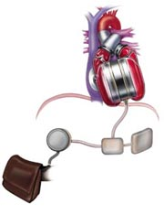
Raw Problem Statement. One of the design requirements of an artificial heart under development is that the blood temperature does not increase by more than .01 °C as it is pumped through the heart. It is known that the pressure rise required for the heart pump is 120 mm Hg and that the average flow rate required is 5 liter/min. Assuming that the electrical and mechanical losses result in a pump efficiency of 25%, estimate the rate of heat removal in Watts required to maintain the allowable temperature increase.

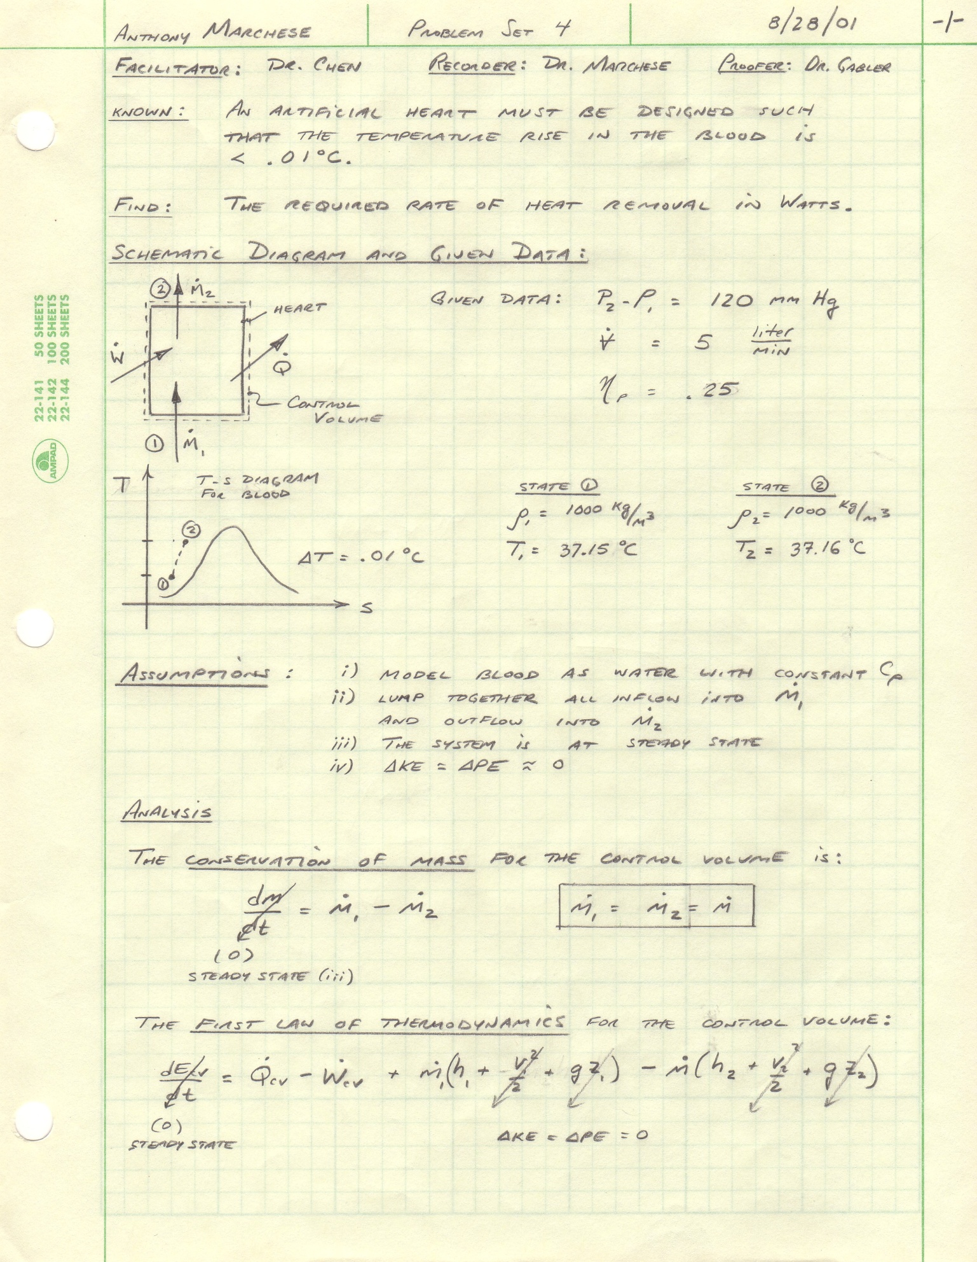
Engineering Model:
Collaborators:
Name

