Technical Objectives:
- Describe ideal gas mixture composition in terms of mass fractions or mole fractions.
- Use the Dalton model (partial pressures) to relate pressure, volume and temperature and to evaluate properties of ideal gas mixtures.
- Apply mass, energy and entropy balances to ideal gas mixtures.
- Demonstrate and understanding of psychrometric terminology including humidity ratio, relative humidity, mixture enthalpy and dew point temperature.
- Use the psychrometric chart to represent humid air conditioning processes.
HW (not to be handed in): 12.4, 12.48, 12.52, 12.57, 12.77
1. Fundamental Parameters
1.1 Mass Fraction, Mole Fraction and Average Molecular Weight. Consider the following box of “humid air” filled with a total mass, m, of a mixture of air and water vapor:

The mass fraction of each constituent (N₂, O₂, H₂O) in the mixture is defined as:

(12.1)

where m_{i} is the mass of the i^{th} species in the mixture and m is the total mass.

The mole fraction of each constituent is defined as:

(12.6)

where n_{i} is the number of moles of the i^{th} species in the mixture and n is the total number of moles.

Note that, by definition, the sum of all mass fractions and mole fractions in a mixture must both add up to 1:

(12.4) (12.8)

Average Molecular Weight. The average molecular weight of a mixture is defined as a mole fraction-weighted average of the molecular weight of the constituents:

(12.9)

Example 0. Calculate the average molecular weight of air, given that air is composed of 78.08% N₂, 20.95% O2, 0.93% Ar, and 0.035% CO₂.

1.2 Partial Pressure. Dalton’s law of partial pressures states that the total pressure, P, is equal to the sum of the partial pressures of each gas.

(12.13)

Physically, the concept of partial pressure means that each gas component acts as if it were the only gas in the container.
Even though air is made up of N₂, O₂, Ar, CO₂, etc, for engineering purposes, we model air as a single component when dealing with humid air calculations. Accordingly, considering again box of humid air, the pressure inside the box can be calculated as follows:

(12.13a)

Where P_{a} is the partial pressure of air in the box and P_{v} is the partial pressure of water vapor in the box.

1.3 Relationship Between Partial Pressure and Mole Fraction. For ideal gases, the mole fraction of each constituent can be calculated simply as the ratio of the partial pressure to the total pressure:

(12.12)

Where i is the i^{th} species in a mixture and P the total pressure. For humid air, the mole fraction of water is thus expressed as:

(12.41b)

1.4 Saturation Pressure and Saturation Mole Fraction. Consider again the box above. For a given temperature there exists a maximum mole fraction of water vapor that can exist in the gas phase. If any additional water were added to the box, the water would condense out as a liquid. The mole fraction at saturation is thus related to the partial pressure at saturation as follows:

(12.41c)

Note, that P_{v,sat} is a function only of temperature and can be found in the steam tables in the back of the book..
Example 1. What is the maximum mole fraction of water that can be present in Fort Collins today?

1.5 Relative Humidity. Relative humidity is defined as the actual mole fraction of water vapor divided by the saturation mole fraction of water vapor:

(12.44)

Example 2. What is the actual mole fraction of water that is present in Fort Collins today?

1.6 Humidity Ratio. Humidity ratio is defined as the ratio of the mass of water vapor to the mass of air:

(12.42)

Assuming ideal gas, and Dalton’s law for the air and water vapor, we can calculate the humidity ratio as follows:

(12-43)

1.7 Mixture Enthalpy. The Enthalpy (BTU or kJ) of a mixture of water vapor and air is the sum of the enthalpy of each component:

(12.45)

Where H_{a} is the enthalpy of the air and H_{v} the enthalpy of the water vapor in BTU or kJ.
In terms of specific enthalpies, this can be written as:

(12-45a)

Where h_{a} and h_{v} are the specific enthalpies of each component in kJ/kg or BTU/lb.
In moist air calculations, it is convenient to define the mixture enthalpy as the enthalpy of the mixture per unit mass of dry air:

(12-46)

For engineering calculations, the enthalpy of the air is calculated from the specific heat and temperature of the air, and the enthalpy of the water vapor is calculated as the saturated vapor enthalpy at the given temperature:

(12-46a)

Example 3. Calculate the enthalpy of air in Fort Collins right now.

1.8 Adiabatic Saturation and Wet Bulb Temperature. Consider the device shown below, in which moist air at a humidity ratio ω and T, P enters a completely insulated system containing liquid water at T_{as}. At the exit, the air is completely saturated and has a humidity ratio of ω’ and a temperature of T_{as}:

Assuming that the process is completely adiabatic, the conservation of energy can be formulated for the above device, which can be solved for the humidity ratio of the incoming air stream, ω, as follows:

(12.48)

Where ω’ is as follows:

(12.49)

Using equations (12.48) and (12.49), one could construct a device such as that drawn above, wherein T_{as} and T are measured, and ω is calculated.
1.9 Wet Bulb Temperature. The adiabiatic saturation temperature, T_{as}, is closely approximated by the wet bulb temperature, which is the temperature that a thermometer would read if its bulb were incased in moist wick. A psychrometer is a device that measures both the wet and dry bulb temperatures at the same time:

(Fig. 12-8)

2. The Psychrometric Chart. The Psychrometric Chart is a graphical representation of the various properties of moist air. It is convenient for solving HVAC problems. To construct the chart, consider once again, a vessel with a fixed volume, V. If water vapor were slowly added to the vessel at a temperature, T, eventually a pressure would be reached wherein the water will condense out:

The pressure at which the water condenses out (i.e. P_{v,sat}) is a function of the temperature:

Recalling the definition of relative humidity, φ, we can also plot lines of constant relative humidity on the chart as follows:

Since humidity ratio, ω, is related to the water vapor pressure:

The y-axis can be replaced with humidity ratio:

Next, we can draw lines of constant enthalpy as calculated from equation (12.46):

Finally, we can plot lines of constant wet bulb temperature:

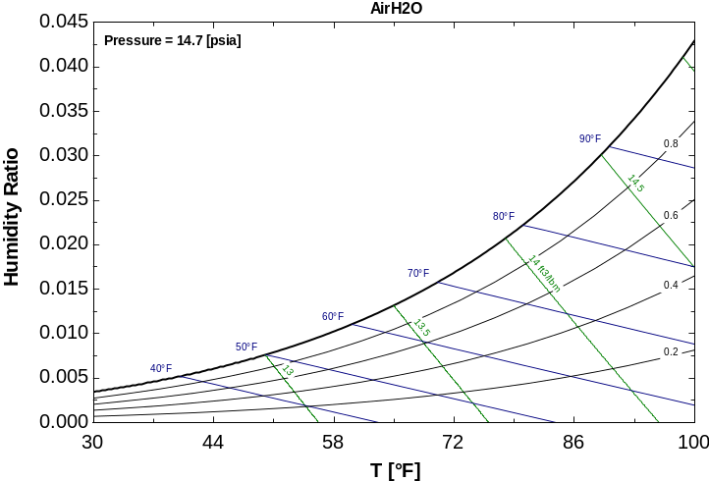

Here is an actual Psychrometric Chart for humid air at sea level:
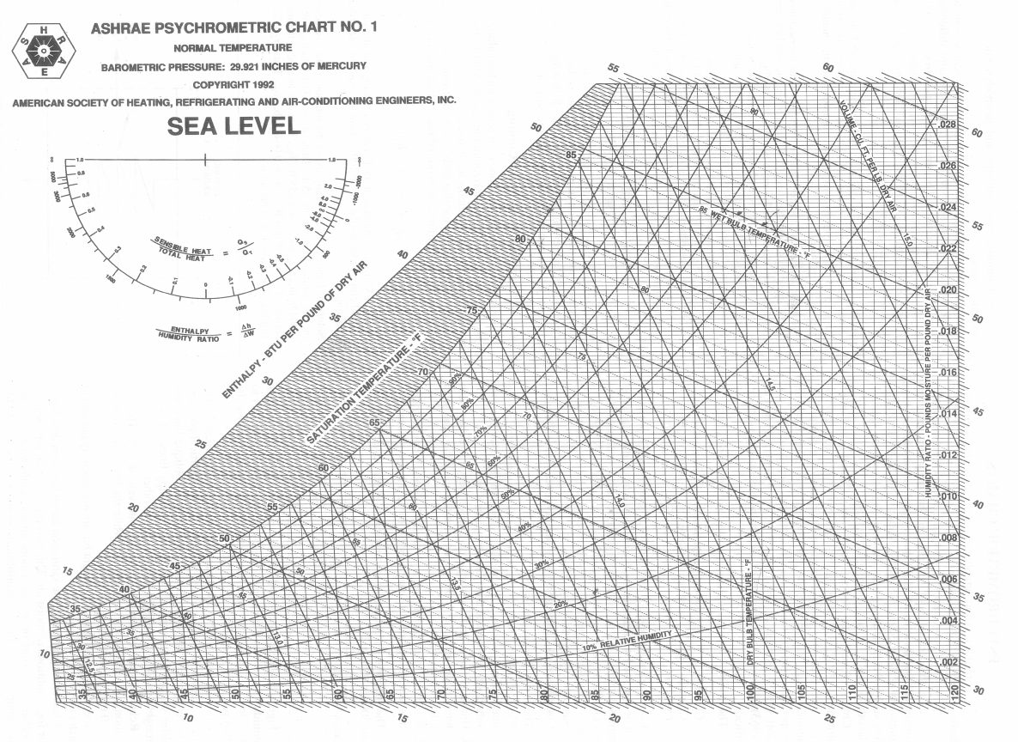

The Psych Chart can be used to solve many practical HVAC problems involving humid air.
3. Moist Air Sensible Heating or Cooling. Consider the following system:
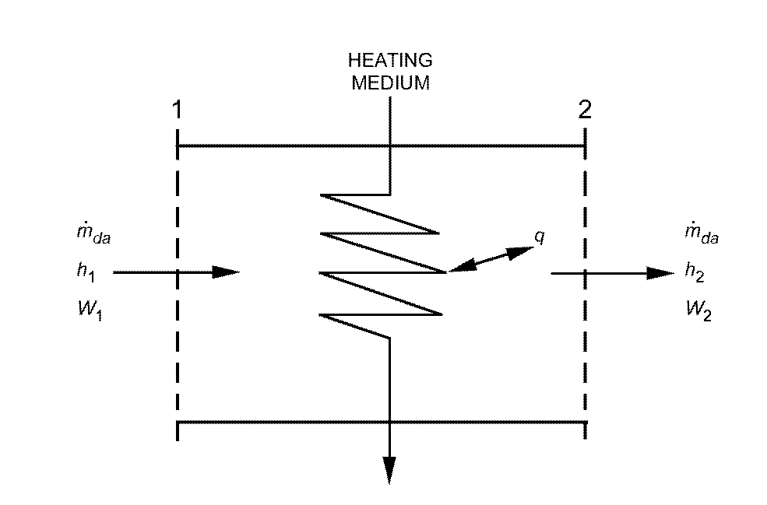

Adding heat alone to or removing heat alone from moist air is represented by a horizontal line on the ASHRAE chart, because the humidity ratio remains unchanged. (This is not necessarily the case if you cool the humid air!). The figure above shows a device that adds heat to a stream of moist air. For steady-flow conditions, the required rate of heat addition is:

Note: all enthalpies are expressed with respect to dry air, so the heat transfer rate is calculated using the mass flow rate of dry air.
Example 4. Heating of a humid air stream.
Moist air, saturated at 35°F, enters a heating coil at a rate of 20,000 cfm. Air leaves the coil at 100°F. Find the required rate of heat addition.
The process can be plotted on the Psych chart as follows:
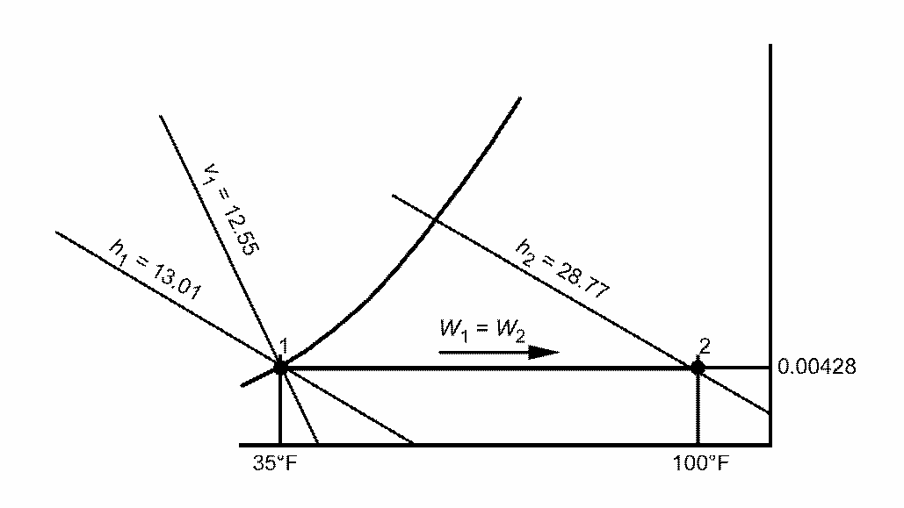

4. Moist Air Cooling and Dehumidification
Consider the following system, in which humid air is cooled, thereby condensing out liquid water:

Moisture condensation occurs when moist air is cooled to a temperature below its initial dew point. Although water can be removed at various temperatures ranging from the initial dew point to the final saturation temperature, it is assumed that condensed water is cooled to the final air temperature before it drains from the system.
The steady-flow conservation of energy yields:

The conservation of mass yields:

Rearranging:

Substituting:

Example 5. Cooling of a humid air stream.
Moist air at 85°F dry-bulb temperature and 50% rh enters a cooling coil at 10,000 cfm and is processed to a final saturation condition at 50°F. Find the tons of refrigeration required.
The process can be shown schematically as follows:
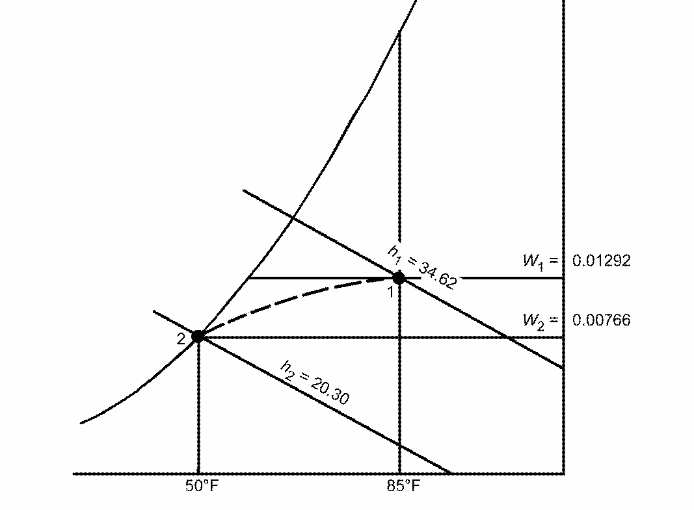
State 1 is located at the intersection of t = 85°F and φ = 50%. Thus,
h₁ =
ω₁ =
v₁ =.
State 2 is located on the saturation curve at 50°F. Thus,
h₂ =
ω₂ =.
From steam tables A-1a,
h_{w2} = h_{f} @ 50 F =
The mass flow of dry air can be calculated as:

And, finally the heat transfer rate can be calculated as:

5. Adiabatic mixing. Consider the following system in which two streams of humid air are mixed.
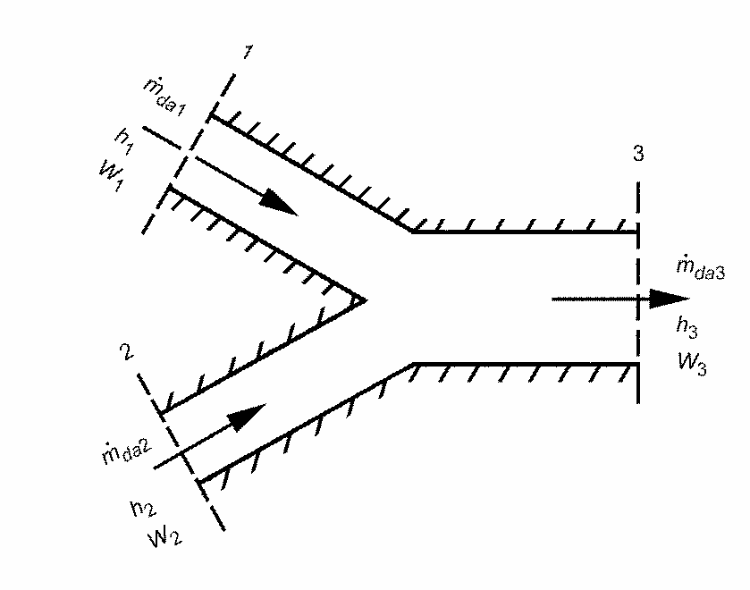
Assuming that the system is adiabatic, we can formulate the conservation of mass and energy for the above system:
Conservation of Energy:

Conservation of mass for dry air:

Conservation of mass for water:

Eliminating m_{a3} gives:

This equation suggests that on the Psych Chart, the state point of the resulting mixture lies on the straight line connecting the state points of the two streams being mixed, and divides the line into two segments, in the same ratio as the masses of dry air in the two streams.

Example 6. Adiabatic mixing example.
A stream of 5000 cfm of outdoor air at 40°F dry-bulb temperature and 35°F wet-bulb temperature is adiabatically mixed with 15,000 cfm of recirculated air at 75°F dry-bulb temperature and 50% rh. Find the dry-bulb temperature and thermodynamic wetbulb temperature of the resulting mixture.
Solution: The process can be shown schematically on the Psych Chart as follows:


