Name: _________________________________ Date:__________________________

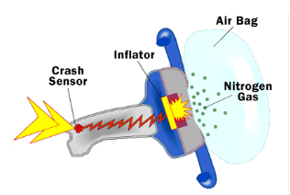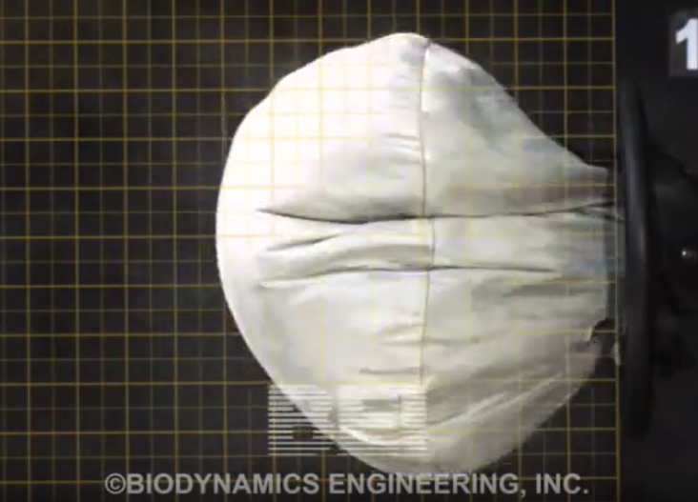

Design an Air Bag Gas Generator using PVC pipe and Rocket Candy

An air bag gas generator is basically a solid rocket motor that rapidly generates gas from a solid fuel. The gas quickly fills an air bag. Earlier versions of air bags used sodium azide as the solid fuel source, which generates N₂ gas upon reaction. The overall chemical reaction for this process is:
2NaN₃ → 2Na + 3N₂

Last Fall, I had my freshman students design and build an air bag generator that uses sucrose (C₁₁H₂₂O₁₁) and potassium nitrate (KNO₃) as propellants and 3 inch Schedule 40 PVC pipe. The following were constraints:
- Maximum pressure inside gas generator, Pc = 115 psig
- Gas generator to be fabricated from 3 inch Schedule 40 PVC end cap and plug
- Air bag to be fabricated from heavy duty plastic trash bag (this did not work!)

Known: An air bag gas generator needs to be designed that will protect a passenger during a head on collision with a stationary barrier at 30 mph.

Find: Calculate the following parameters, given the above design constraints.
- The total force of the decelerating human being to be counteracted by the bag [lbf]
- The pressure required in the bag to counteract the force [psig]
- The required volume of the air bag [m³]
- The total mass of gas in the airbag after inflation [kg]
- Total mass of KNO₃ [g] required for the air bag gas generator
- Total mass of sucrose [g] required for the air bag gas generator
- The mass flow rate required for the air bag gas generator [kg/s]
- Total surface area of rocket candy in the gas generator [in²]
- Total area of holes in gas generator [in²]

Given: The regression rate [in/s] for stoichiometric rocket candy is given by:
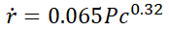
where P_{c} is in psia and the solid density of the rocket candy is 1800 kg/m³. The temperature in the bag after inflation is assumed to be 500 K.

