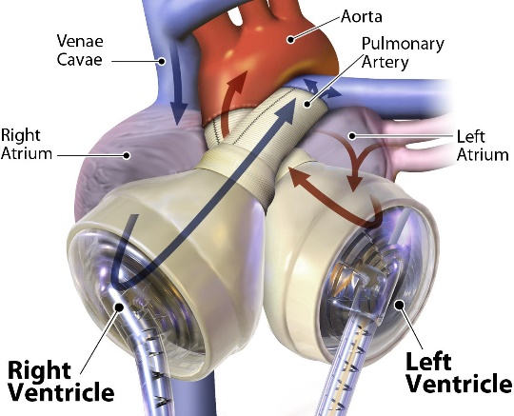

Syllabus

Course: KEY 192A Engineering Key Seminar
Meeting times: Monday 4:00 - 5:50 p.m. (ENGR B3)

Instructor: Prof. Anthony J. Marchese
marchese@colostate.edu
Office: Scott Bioengineering 104
Phone: (970) 491-2328
Syncardia Artificial Heart
Instructor Office Hours: TBA

Teaching Assistants: Isabel Valdez (Isabel.Valdez@rams.colostate.edu)
Tyler Pedersen (Tyler.Pedersen@rams.colostate.edu

Required Reading: Rocket Boys by Homer Hickam, Delta; Reprint edition (January 11, 2000).
Course Description
The goal of the Engineering Key Community Seminar is to introduce freshman engineering students to the engineering profession by examining the impact of engineering research, design, analysis and development on society. Students will also be introduced to the unifying engineering science principles such as the conservation of mass, momentum and energy, materials science, mathematical algorithms and how these principles (along with manufacturing techniques, cost, safety requirements, environmental considerations and intellectual property) impact the design of engineering systems. Students will also develop technical communication, time management and critical thinking skills.
Grading Policy
Attendance (30%). The class meets once per week and attendance is required.
Class Participation (30%). The class format will be interactive and participation in class discussions is expected. In class exercises will be conducted in teams and individually.
Homework/Project (40%). Short homework assignments will be given each week in support of the topics covered that week. In addition, there will be a semester-long design project.
Homework Format and Grading
Assignments are due at the beginning of the class on the day announced by the instructor. Late assignments will not be collected (Late = 0), but the lowest homework grade will be dropped. Assignments must be done on engineering paper in the format specified by the instructor (Known, Find, Given, Schematic Diagram, Engineering Model, Analysis). A sample of the required format is attached.
Attendance and Lateness Policy
Attendance at all class sessions is mandatory. Please contact me ahead of time if you cannot make it to class.
Course Website
Information on this class (including this syllabus) will be posted on the web at: http://www.engr.colostate.edu/~marchese/key192a

Week | Date(s) | Assigned Reading | Topic(s) | Learning Lab | Engineering Solution of the Week
1 | Aug. 26 | Rocket Boys  Ch. 1 to 3 | Introductions  Introduction to Assigned Reading | Thermal Energy  Transport of Thermal Energy  Conduction Heat Transfer | Space Shuttle Thermal Protection System
2 | Sept. 2 | No Class – Labor Day
3 | Sept. 9
4 | Sept. 16
5 | Sept. 23
6 | Sept. 30
7 | Oct. 7
8 | Oct. 14
9 | Oct. 21
10 | Oct. 28
11 | Nov. 4
12 | Nov. 11
13 | Nov. 18
14 | Nov. 25 | No Class – Thanksgiving Break
15 | Dec. 2.
16 | Dec. 9
17 | Dec.16 | Finals Week

Example Homework Problem and Solution Technique

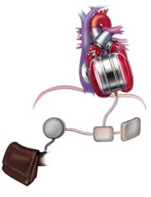
Raw Problem Statement. One of the design requirements of an artificial heart under development is that the blood temperature does not increase by more than .01 °C as it is pumped through the heart. It is known that the pressure rise required for the heart pump is 120 mm Hg and that the average flow rate required is 5 liter/min. Assuming that the electrical and mechanical losses result in a pump efficiency of 25%, estimate the rate of heat removal in Watts required to maintain the allowable temperature increase.

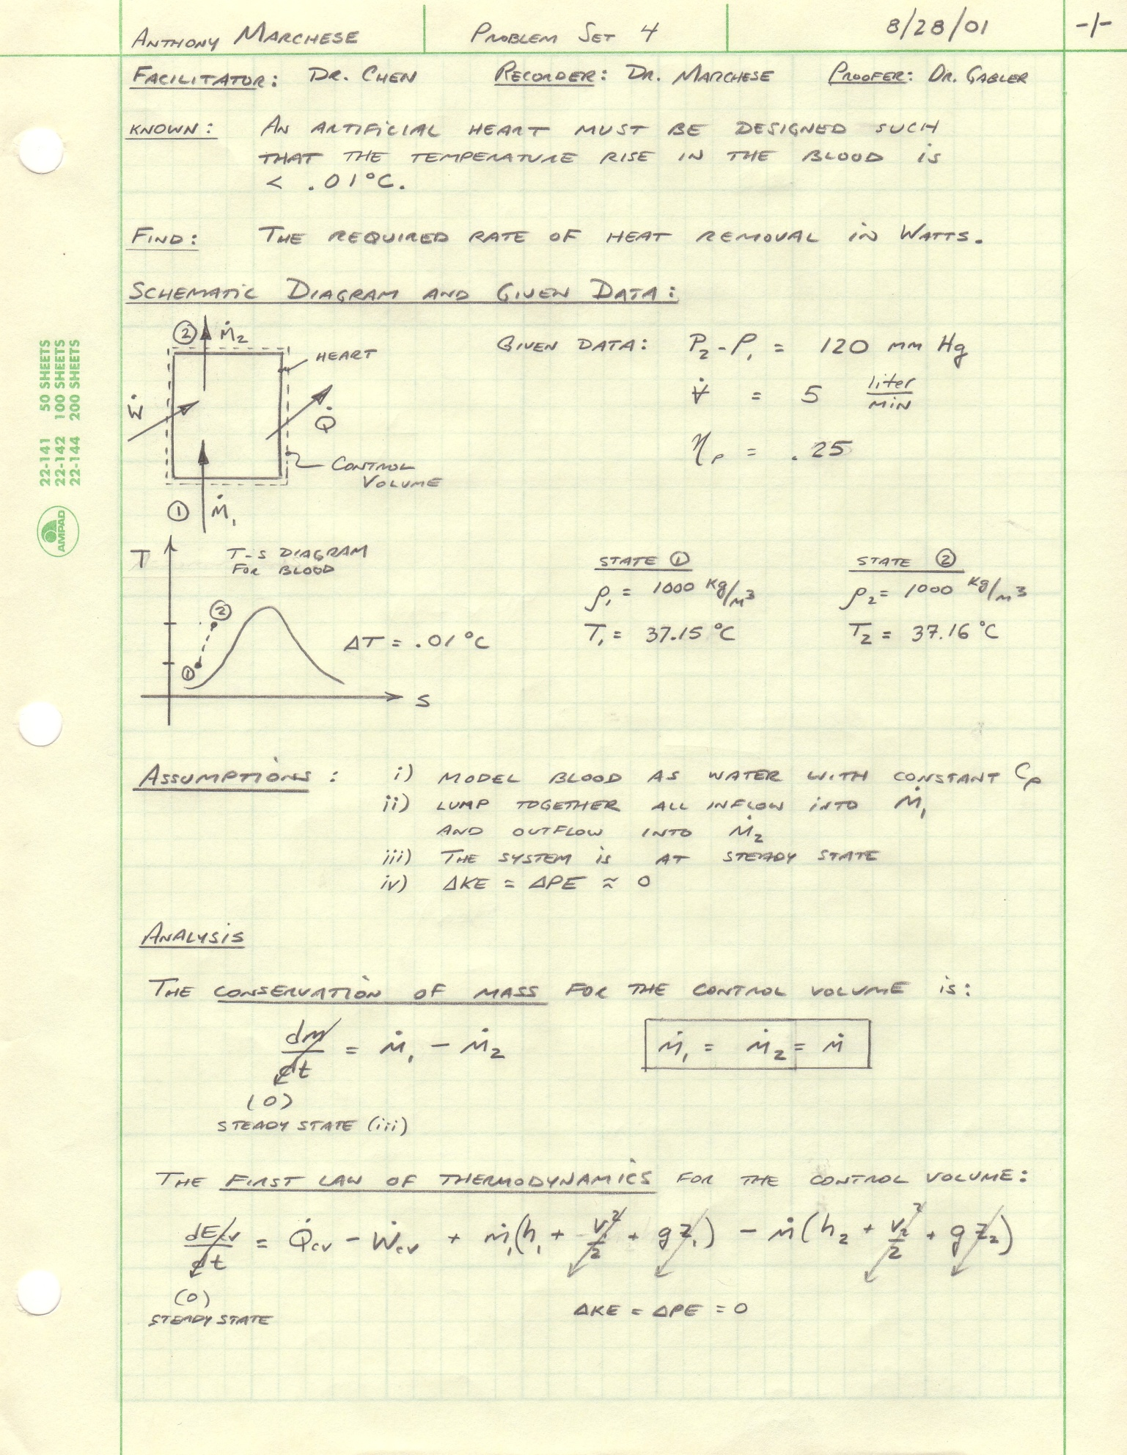
Collaborators:
Date
Engineering Model:
Name

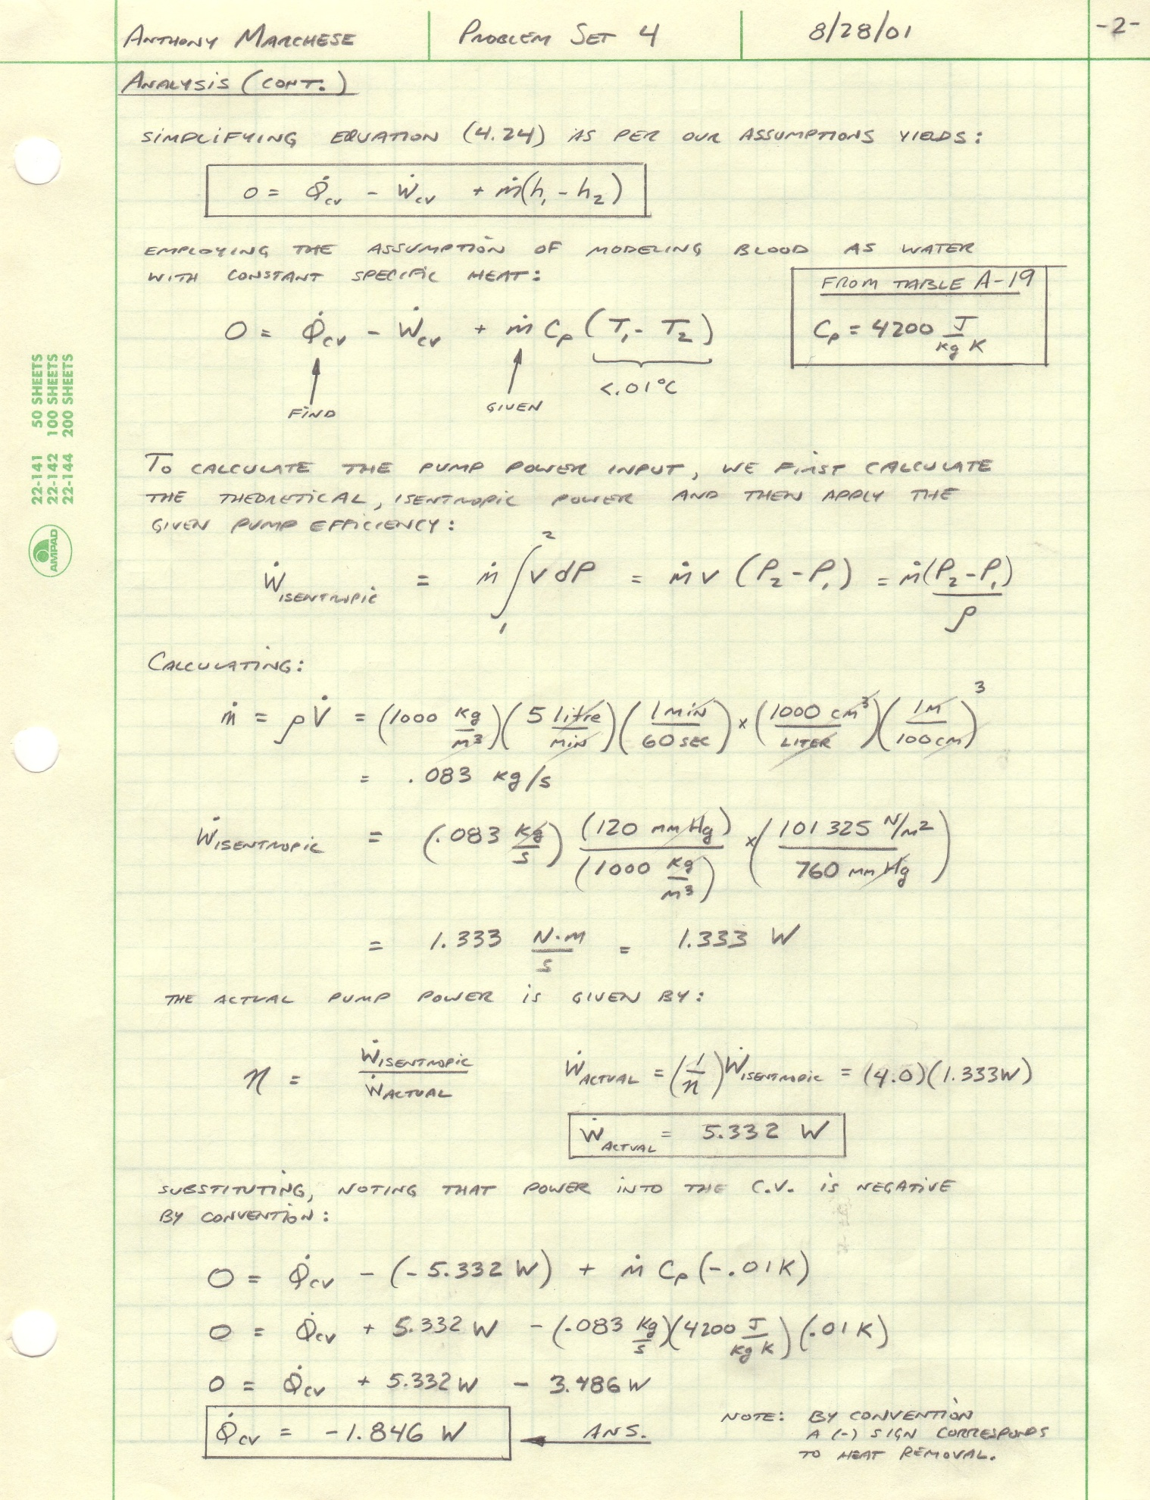
Name
Date

