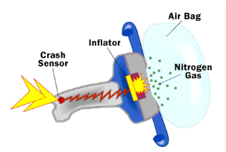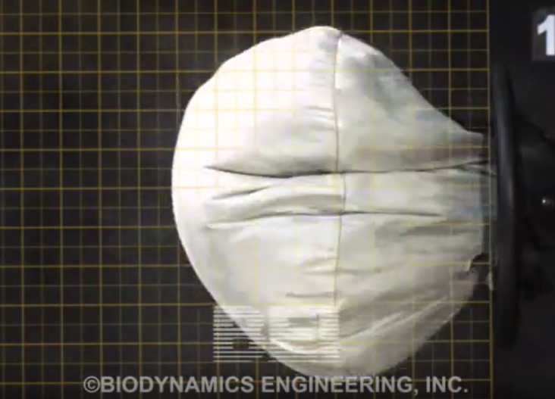

Design and Build a “Rocket Candy” Air Bag Gas Generator

This semester, our design project will entail designing and building a gas generation system for an automotive air bag that uses a chemical solid propellant called “rocket candy” to rapidly inflate an air bag for automotive use. Rocket Candy is a mixture of potassium nitrate (KNO₃) oxidizer and sucrose (C₁₁H₂₂O₁₁) fuel.
Primary Topic: Engineering Analysis and Design
Supporting Topics: Algebra, calculus (MATH 117,118,124, 125, 126, 160); Newton’s Laws of Motion (PHYS 141); Chemical Reactions (CHEM 111)
Technical Objectives:
- Explain how a solid rocket motor works and how this same principle is used to generate gas to rapidly fill an air bag.
- Discuss and calculate the parameters necessary to design an air bag gas generator to protect a human occupant during a collision.
- Calculate the ratio of fuel to oxidizer by mass required for a stoichiometric “rocket candy” mixture.
- How a Solid Rocket Motor Works and How This Relates to an Air Bag Generator.
Chemical rocket propulsion systems employ chemical reactions between one or more propellants to generate thermal energy, which is converted to kinetic energy in a nozzle to produce thrust. A solid rocket motor combines the propellant storage system, feed system and combustion chamber into one. The propellants are mixed before flight and stored in solid form.

Air bag gas generators work on a similar principle, but in a different form factor.

An air bag gas generator is basically a solid rocket motor that rapidly generates gas from a solid fuel. The gas quickly fills an air bag. Earlier versions of air bags used sodium azide as the solid fuel source, which generates N₂ gas upon reaction. The overall chemical reaction for this process is:

2NaN₃ → 2Na + 3N₂

Group Learning Exercise 1.
This semester, our design project will entail designing and building a gas generation system for an automotive air bag that uses a chemical solid propellant called “rocket candy” to rapidly inflate an air bag for automotive use. Rocket Candy is a mixture of potassium nitrate (KNO₃) oxidizer and sucrose (C₁₁H₂₂O₁₁) fuel.

What are some of the design parameters that you will have to determine to complete this design? How would you go about determining the design specifications for each of these parameters?

- How to calculate force that the bag has to counteract?

- How to calculate the pressure requirements for the bag?

- How to determine the size of the bag (volume and dimensions)?

- How to calculate required mass flow rate of gas generator? Given the pressure, temperature and size of the bag, we can calculate the total mass in the bag. To calculate the mass flow rate, we need to know the time required to fill up the bag.

- How to mix and formulate rocket candy? Rocket Candy is a mixture of potassium nitrate (KNO₃) oxidizer and sucrose (C₁₁H₂₂O₁₁) fuel. We can estimate the ratio of fuel to oxidizer assuming that a stoichiometric mixture would result in optimum performance. A stoichiometric mixture would produce products of CO₂, H₂O and N_{2.} To determine the mass ratio, one would balance the chemical reaction to find the molar ratio and then convert to mass ratio based on the molecular weights.

- How to calculate the quantity of rocket candy required? Since we already calculated the total mass required to fill the air bag, we can then determine the total initial mass of fuel and oxidizer needed in the gas generator based on the above stoichiometric reaction.

- How to calculate the total “throat area” for the gas generator? This one is more difficult and requires a rocket scientist. Fortunately, your Engineering Key Community instructor is a rocket scientist.

- How to control when to ignite the gas generator?

- How to ignite the rocket candy?

