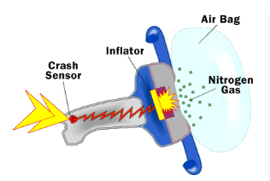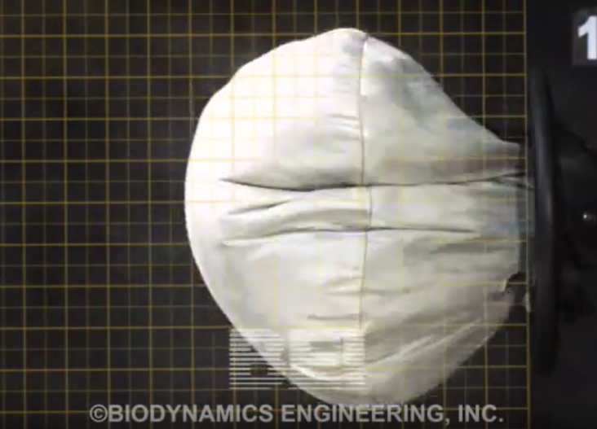

Design and Build a “Rocket Candy” Air Bag Gas Generator

This semester, our design project will entail designing and building a gas generation system for an automotive air bag that uses a chemical solid propellant called “rocket candy” to rapidly inflate an air bag for automotive use. Rocket Candy is a mixture of potassium nitrate (KNO₃) oxidizer and sucrose (C₁₁H₂₂O₁₁) fuel.
Primary Topic: Engineering Analysis and Design
Supporting Topics: Algebra, calculus (MATH 117,118,124, 125, 126, 160); Newton’s Laws of Motion (PHYS 141); Chemical Reactions (CHEM 111)
Technical Objectives:
- Explain how a solid rocket motor works and how this same principle is used to generate gas to rapidly fill an air bag.
- Discuss and calculate the parameters necessary to design an air bag gas generator to protect a human occupant during a collision.
- Design the air bag gas generator to fill the air bag rapidly enough to save the life of the human occupant.
- How a Solid Rocket Motor Works and Relation to an Air Bag Gas Generator.
Chemical rocket propulsion systems employ chemical reactions between one or more propellants to generate thermal energy, which is converted to kinetic energy in a nozzle to produce thrust. In a solid rocket motor, a solid oxidizer and solid fuel are mixed and stored within the combustion chamber prior to flight, and the propellant storage system, feed system and combustion chamber are combined into a single, simple system. The propellants are mixed before flight and stored in solid form. Examples include the Space Shuttle Solid Rocket Boosters (SRMs).

Automotive air bag gas generators work on a similar principle, but in a different “form factor”.

An air bag gas generator is basically a solid rocket motor that rapidly generates gas from a solid fuel. The gas quickly fills an air bag. Earlier versions of air bags used sodium azide as the solid fuel source, which generates N₂ gas upon reaction. The overall chemical reaction for this process is:
2NaN₃ → 2Na + 3N₂

Group Learning Exercise 1.
This semester, our design project will entail designing and building a gas generation system for an automotive air bag that uses a chemical solid propellant called “rocket candy” to rapidly inflate an air bag for automotive use. Rocket Candy is a mixture of potassium nitrate (KNO₃) oxidizer and sucrose (C₁₁H₂₂O₁₁) fuel.

What are some of the design parameters that you will have to determine to complete this design? How would you go about determining the design specifications for each of these parameters?

- How to calculate force that the bag has to counteract? The force, F [N], that the airbag must counteract is created by the deceleration, a [m/s²] of the human occupant, who will need to decelerate from some initial velocity, v_{i}, to a final velocity v_{f}=0 over a very short distance.

- How to calculate the pressure requirements for the bag? The air bag have enough pressure to counteract the force from the decelerating human occupant. Pressure, by definition is defined as force per unit area:

- How to determine the size of the bag (volume and dimensions)? The volume of the inflated air bag can be estimated from the dimensions of an automobile. The critical dimension, in this case, would be the distance between the human occupant and the steering column.

- How to calculate required mass flow rate [kg/s] generated by the gas generator? Given the pressure of the gas in the bag, an estimated temperature of the gas, and the estimated volume of the bag, we can calculate the total mass of gas, m [kg] in the bag from the ideal gas law:

To calculate the mass flow rate [kg/s], we need to know the time required to fill up the bag. We can estimate the filling time, Δt [s], from the video.

- How to mix and formulate rocket candy? Rocket Candy is a mixture of potassium nitrate (KNO₃) oxidizer and sucrose (C₁₁H₂₂O₁₁) fuel. From detailed computations using a NASA chemical equilibrium code, we find that the reaction of these two chemicals produced the following gaseous exhaust products: CO₂, H₂O, KOH and N_{2.} And, we find that the optimal molar ratio of potassium nitrate to sucrose is 6. We can convert this to an oxidizer to fuel mass ratio (O/F) given the molecular weights of each propellant:

- How to calculate the quantity of rocket candy required? Since we already calculated the total mass required to fill the air bag, we can then determine the total initial mass of fuel and oxidizer needed in the gas generator based on the above stoichiometric reaction.

- How to calculate the total “throat area” for the gas generator? This one is more difficult and requires a rocket scientist. Fortunately, your Engineering Key Community instructor is a rocket scientist.

- How to control when to ignite the gas generator?

- How to ignite the rocket candy?

