Name: _________________________________ Date:__________________________

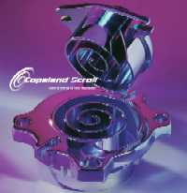

The Scroll Compressor: Engineering Ethics Question

First patented in 1905, it took about 80 years before an efficient scroll compressor could be manufactured that could compete with reciprocating compressors. Today, the scroll compressor is widely used in residential air conditioners, commercial air conditioners and vacuum pumping applications.

Imagine yourself as a newly hired engineer (fresh out of school) working on the development of a new scroll compressor for your company. One of your first assignments is a project called Competitive Assessment, which involves acquiring, disassembling, measuring, instrumenting and testing your competitor’s scroll compressors. Your company currently purchases 250,000 compressors per year from one of your competitors and the contract specifically says that your company is not allowed to disassemble and test their product. When you point this out to your boss, he says, “we really need to understand how their product works, so that we can design a better one and not have to purchase the product from them. Besides, they know that there is no way to enforce this clause. And, this is your assignment”.

Question: What would you do?

