Name: _________________________________ Date:__________________________

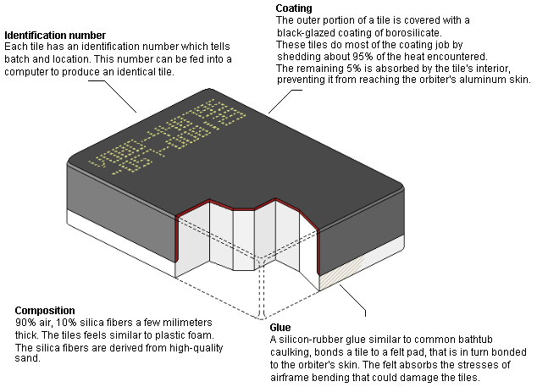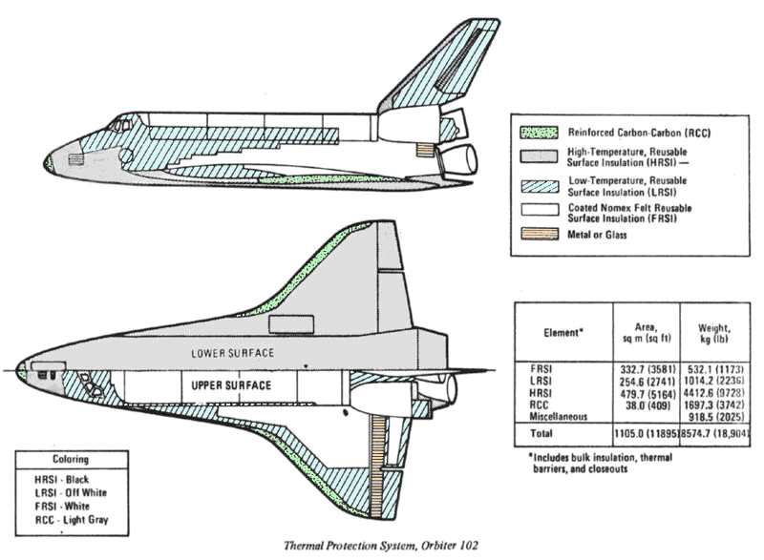

Space Shuttle Thermal Protection System: LI-900 Silica Insulation Tiles

On February 1, 2003, the Space Shuttle Columbia catastrophically disintegrated during reentry resulting in the loss of the space vehicle and the loss of life of all of the astronauts on board. After an exhaustive investigation, it was found that the failure was caused by a breach in the thermal protection system. The breach was caused by a large piece of insulating foam that broke away from the external tank and impacted the leading edge of the left wing during launch.

An excerpt from the official investigation details how the breach in Columbia’s left wing resulted in the ultimate loss of the space vehicle:

“[The] conclusion is that Columbia re-entered Earthʼs atmosphere with a preexisting breach in the leading edge of its left wing in the vicinity of Reinforced Carbon-Carbon (RCC) panel 8. This breach, caused by the foam strike on ascent, was of sufficient size to allow superheated air (probably exceeding 5,000 degrees Fahrenheit) to penetrate the cavity behind the RCC panel. The breach widened, destroying the insulation protecting the wingʼs leading edge support structure, and the superheated air eventually melted the thin aluminum wing spar. Once in the interior, the superheated air began to destroy the left wing.”

Known. Heat flux [W/m²] is defined as heat per unit area. For the conduction of heat, the heat flux can be calculated using the following equation, where k is the thermal conductivity [W/m°C], ΔT is the temperature difference and Δx is the thickness of a material:
$$q=−k\frac{\text{dT}}{\text{dx}}≈−k\frac{ΔT}{Δx}$$
Given: The thermal conductivity of the LI-900 thermal insulation material is 0.048 W/m°C and the thermal conductivity of aluminum is 250 W/m°C.
Find: (a) The heat flux (W/m²) through a 2-inch thick section of LI-900 subject to a ΔT of 2500 °C, (b) the heat flux (W/m²) through a 0.25 inch thick section of aluminum subject to the same temperature difference and (c) compare these values to the heat flux (heat per unit area; W/m²) at the surface of a 100 W lightbulb and to the radiant heat flux that the Earth receives from the Sun.

Columbia Accident Investigation Board Report, Volume 1, August 2003

